Easy Read – About the Disability Dialogue
 | We are called the Disability Dialogue.
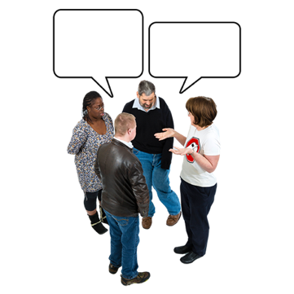 | The Disability Dialogue is a group of people who come together to talk about things they care about and want to make better.
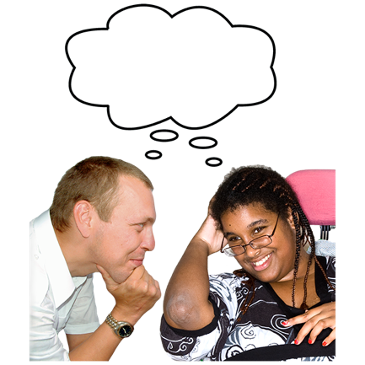 | The Disability Dialogue is a new way to think about how to fix problems for people with disability.
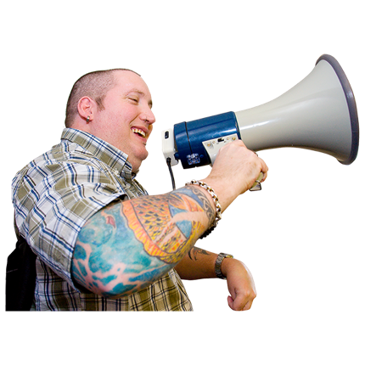 | The Disability Dialogue makes sure that people with disability have their voices heard when they have ideas.
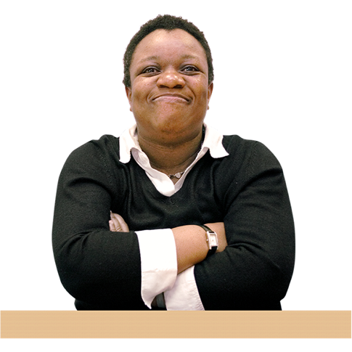 | People with disability are in charge of the Disability Dialogue.
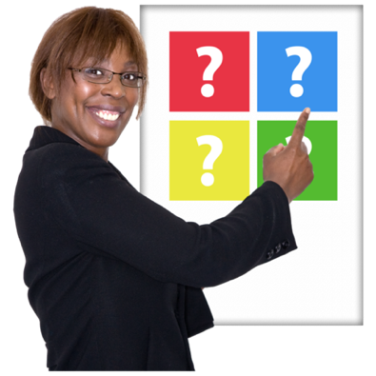 | Important decisions about how to do things are made by people with disability.
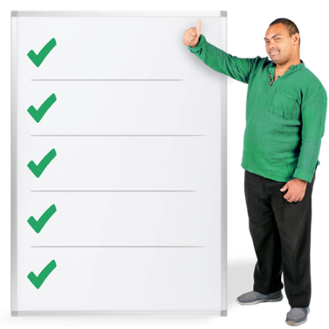 | This is because people with disability are very good at knowing what does and does not work for them.
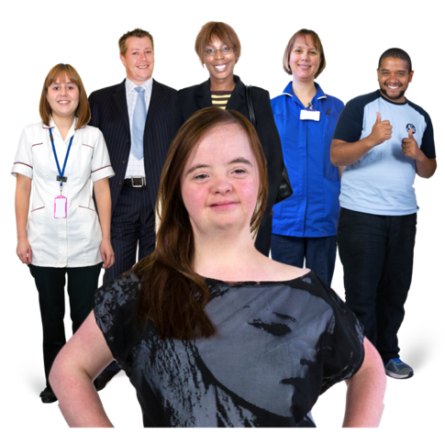 | The Disability Dialogue welcomes anyone who wants to make things better for people with disability to join them.

What we do
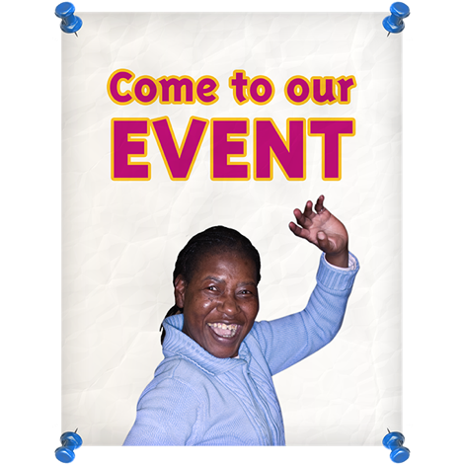 | The Disability Dialogue holds events for people to join in.
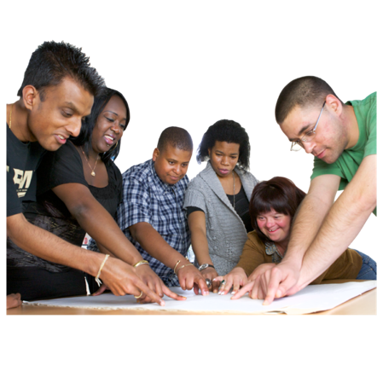 | The Disability Dialogue also does projects for people to be a part of.
 | There is a video that shows more about the Disability Dialogue. You can watch it here:  https://www.youtube.com/watch?v=Hsxbr0ZvyX4

Groups involved in the Dialogue
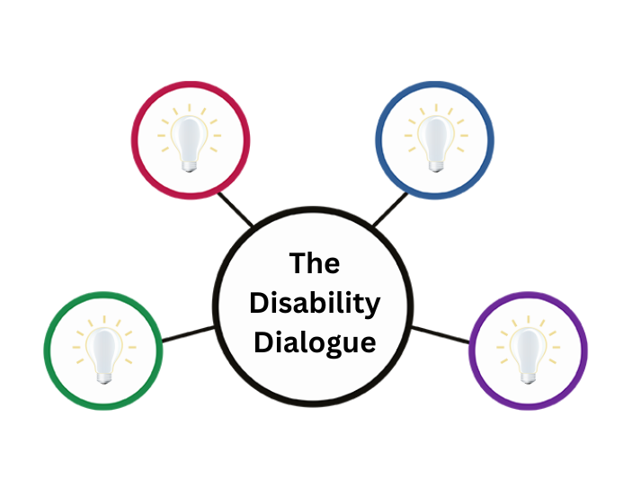 | There are four groups that helped create the Disability Dialogue.
       | They are:  - Disability Advocacy Network Australia  - Inclusion Australia  - Melbourne Disability Institute  - Alliance 20
 | These four groups are called partners and they help run the Disability Dialogue.
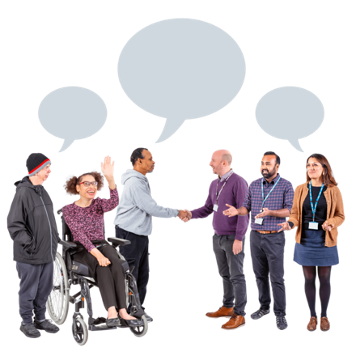 | The Dialogue hopes there will be more partners as it keeps growing.
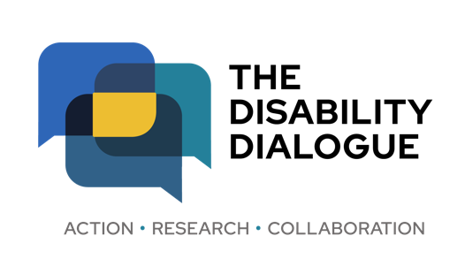 | If you have any questions please send them to  info@disabilitydialogue.com.au.

