Let’s talk about work!

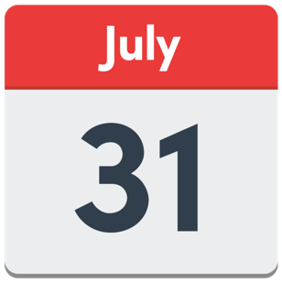 | Come to a talk about work and having a job  The talk is on Tuesday July 30 from 7pm to 8.30 on Zoom.  The Disability Dialogue is having this talk.
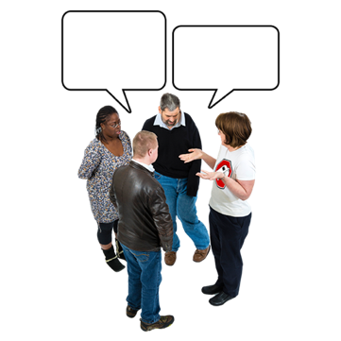 | The Disability Dialogue is a group of people with disability and others who talk about things they care about and want to make better.
 | People with disability often have a hard time finding and keeping a job.
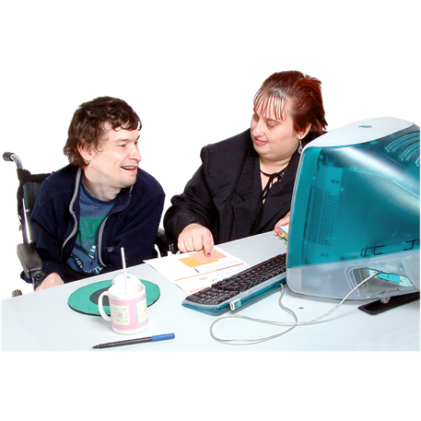 | We want to hear what you think about having a job.
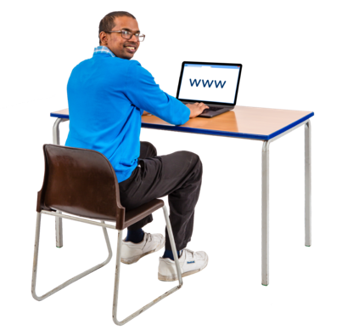 | Please register by using this link: https://disabilitydialogue.com.au/events/making-disability-work/
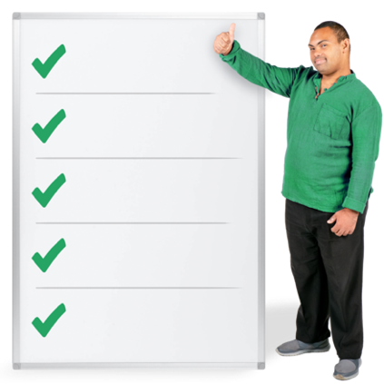 | To register to you will need to tell us  - Your name  - Your email address  - Your post code  - If you or someone you know has a disability  - What support you need to be part of this event
 | We will send the Zoom link to you in an email.
 | If you have any questions, please send them to info@disabilitydialogue.com.au.
 | We hope to see you there.

