Let’s talk about people with disabilities

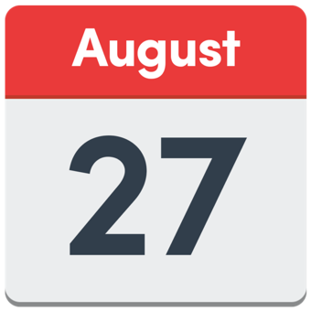 | Come to a talk about what the Government said about the Disability Royal Commission.  The talk is on Tuesday August 27 from 7pm to 8.30 AEST on Zoom.  The Disability Dialogue is having this talk.
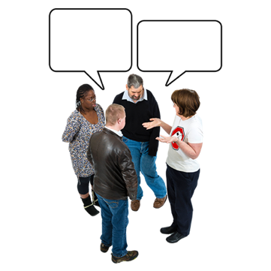 | The Disability Dialogue is a group of people with disabilities and others who talk about things they care about and want to make better.
 | The Disability Royal Commission (DRC) was about how people with disabilities are treated badly in Australia.
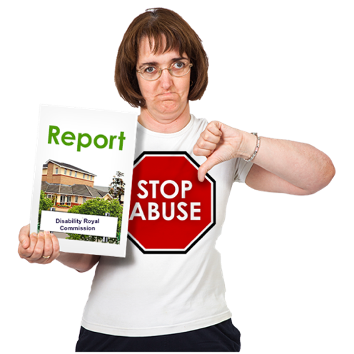 | The DRC made a report to tell the Government how to make Australia better for people with disabilities.
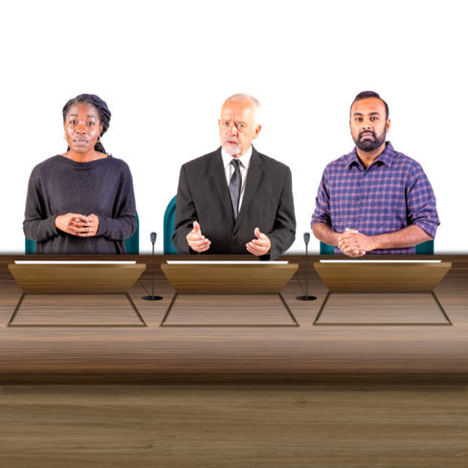 | The Government responded to that report.
 | A lot of people with disabilities and their supporters were disappointed with what the Government said.
 | Come to our talk to tell us how you feel about this.
 | Please register by using this link: https://disabilitydialogue.com.au/events/drc-wtf-where-to-from-here-after-the-governments-response/
 | To register you will need to tell us  - Your name  - Your email address  - Your post code  - If you or someone you know has a disability  - What support you need to be part of this event
 | We will send the Zoom link to you in an email.
 | If you have any questions, please send them to info@disabilitydialogue.com.au.
 | We hope to see you there.

