Event rules

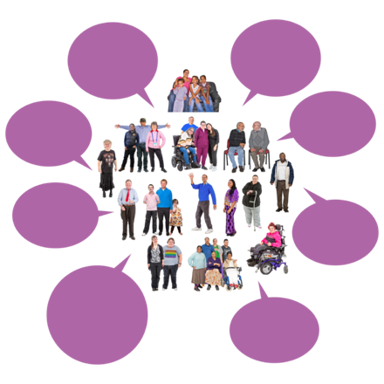 | Open Dialogues are a safe place for people to share their ideas.
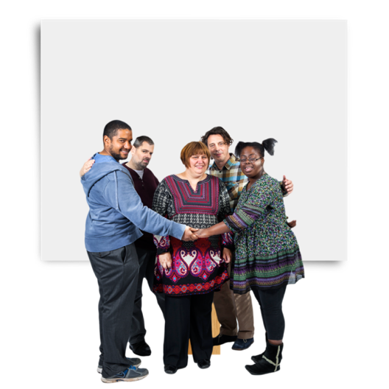 | We want everyone to feel safe and heard.
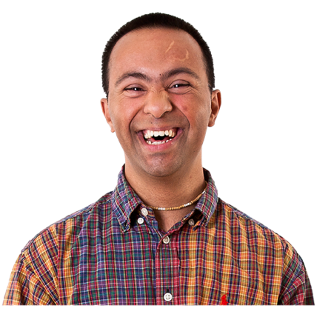 | We also want everyone to have some fun.
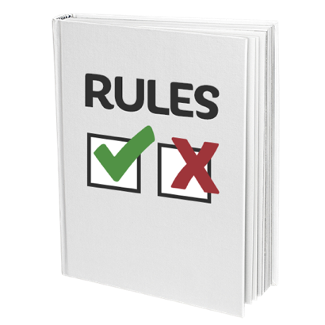 | There are rules to make sure we all feel safe together.
 | When you come to an Open Dialogue you promise to  - Be respectful  - Be inclusive  - Help everyone feel safe and heard
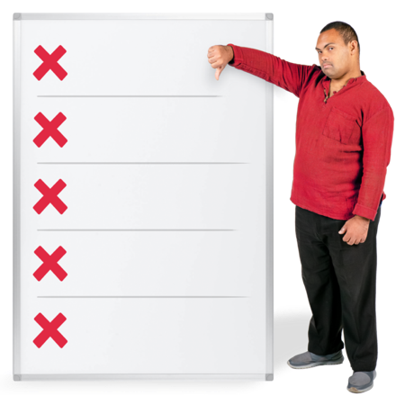 | You also promise to not  - Say anything mean to a person or group  - Say anything mean about a person or group  - Talk about things that have nothing to do with what is being said
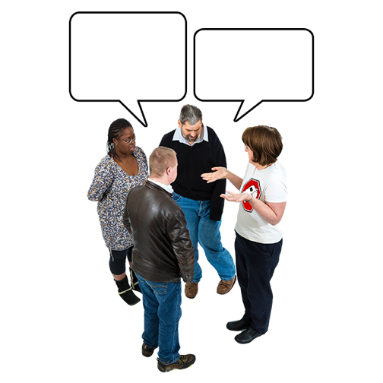 | These rules help make everyone feel like they can be part of the talk.
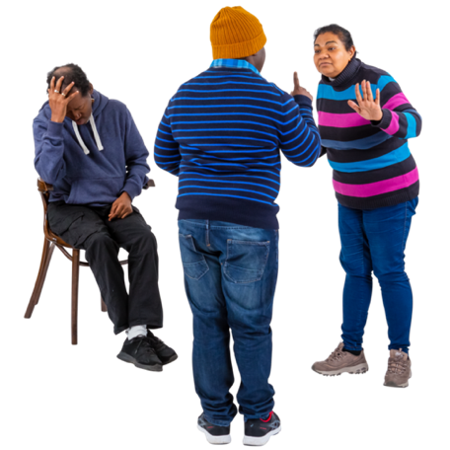 | If someone break these rules they will be asked to leave the event.
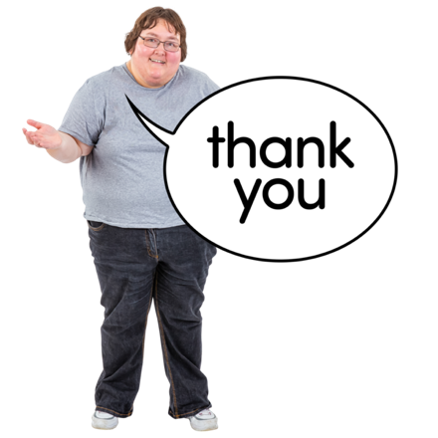 | Thank you for helping us make the Disability Dialogue a safe and inclusive event.

