Let’s talk about people with disabilities on TV

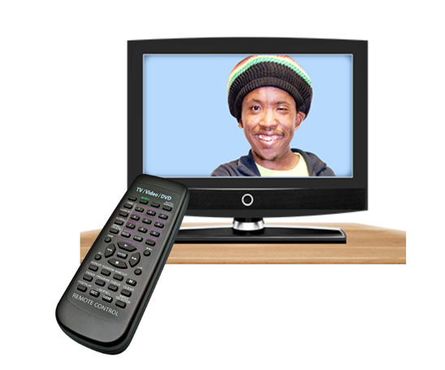 | Come to a talk about people with disabilities on TV.
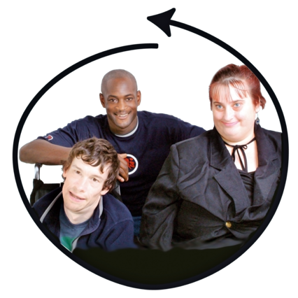 | We want to know how we can make TV and movies more inclusive for people with disabilities.
 | The talk is on Tuesday November 26 from 7pm to 8.30 AEDT on Zoom.  The Disability Dialogue is having this talk.
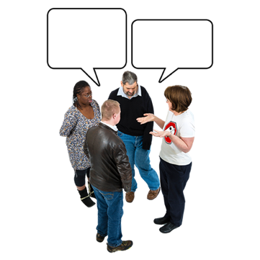 | The Disability Dialogue is a group of people with disabilities and others who talk about things they care about and want to make better.
 | We will also share important news for people with disability.
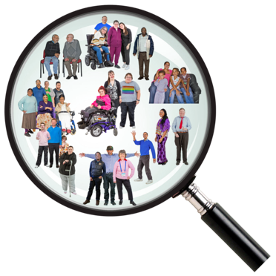 | Then we will talk about what we learned from our Disability Discovery Project survey.
 | The Disability Discovery Project survey asked people with disabilities what supports they wanted to make their lives better.
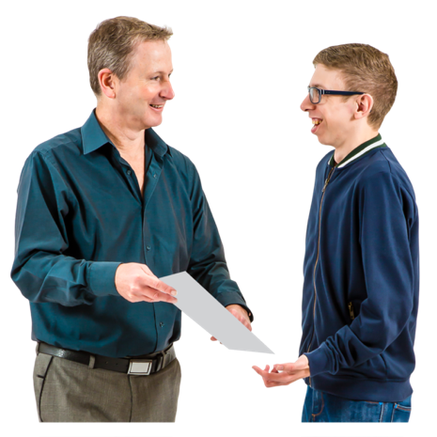 | We will share what people said.
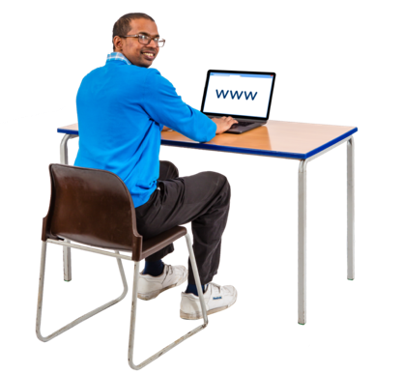 | Please sign up by using this link: https://disabilitydialogue.com.au/events/reel-inclusion-disability-in-film-and-tv/
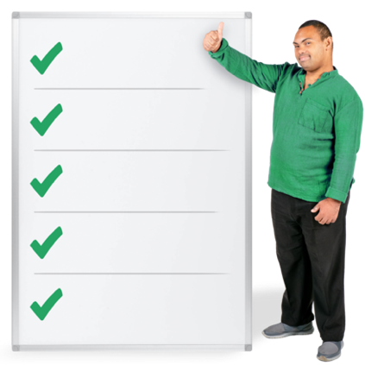 | To register you will need to tell us  - Your name  - Your email address  - Your post code  - If you or someone you know has a disability  - What support you need to be part of this event
 | We will send the Zoom link to you in an email.
 | If you have any questions, please send them to info@disabilitydialogue.com.au.
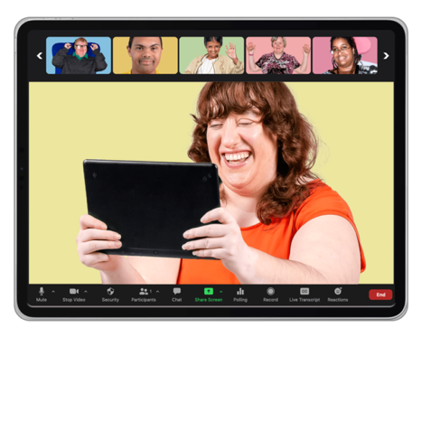 | We hope to see you there.

