Event summary from the Disability Dialogue:
Our talk about friendship

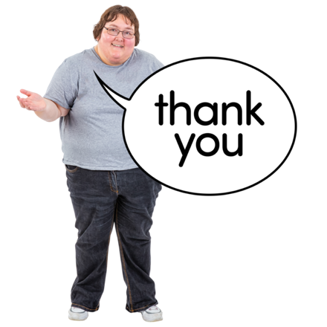 | Thank you to everyone who came to our event about friendship with the Disability Dialogue.
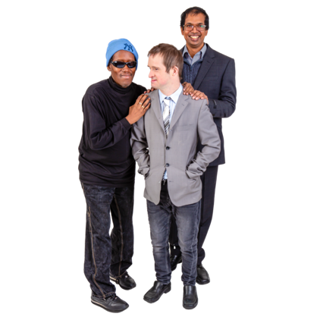 | The Disability Dialogue is a group of people who come together to talk about important things for people with disability.  We are supported by these organisations:  - DANA  - Inclusion Australia  - Alliance 20  - Melbourne Disability Institute  And funding from the Federal Government.
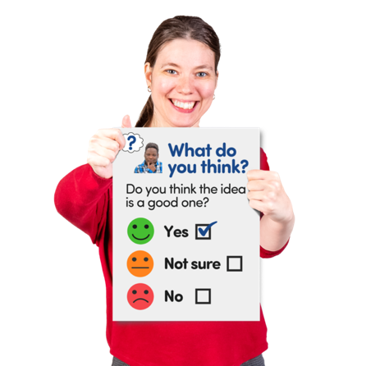 | We want to know what you thought of the event.  If you want, you can fill out this short survey here: https://forms.gle/uK5ggsHMD4pejVedA
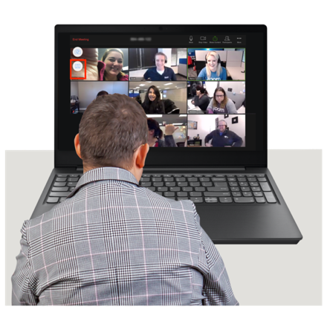 | You can watch the recording of the event here:  https://www.youtube.com/watch?v=3NwoHQBkrAA
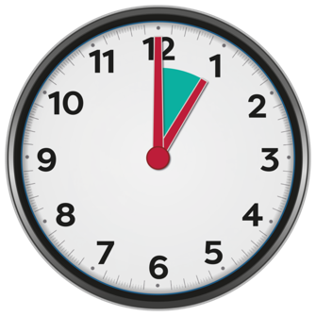 | The event was an hour long.
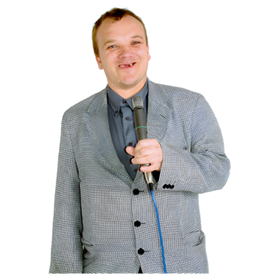 | There were seven speakers.
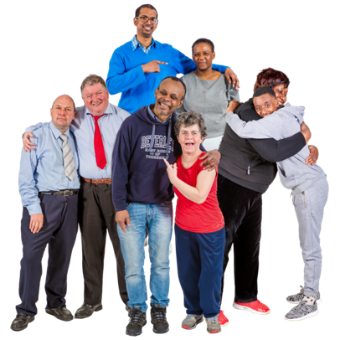 | The talk started with Emma Myers, Todd Winther and Elly Desmarchelier talking about friends in their lives.
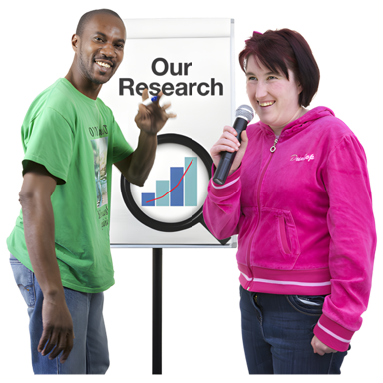 | Sally Robinson and Tim Cahalan talked about what they learned from studying what makes people with disability feel lonely.
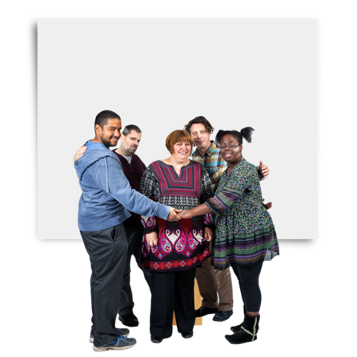 | They said that people feel included when they are treated fairly.
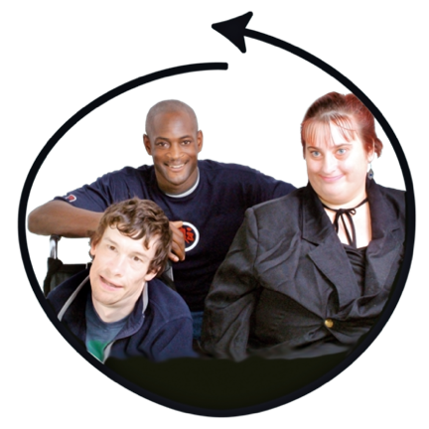 | They also shared tips about how to make people feel included and safe.
 | You can learn more about Sally and Tim’s work about friendship here: https://www.ourvoicesa.org.au/our-work
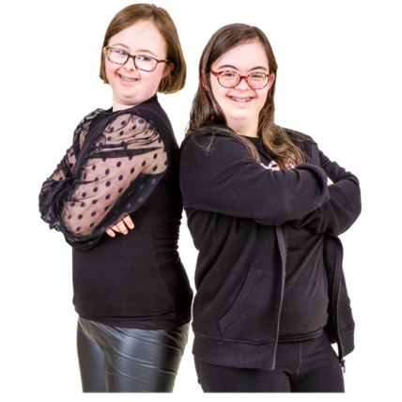 | Then we heard Saranna Schultz and Megan Lampa talk about how they became friends.
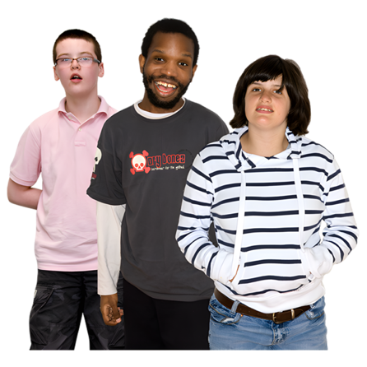 | They became friends through a program for young people with disability.
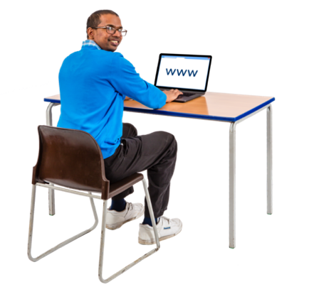 | You can learn more about that program here: https://cpactive.org.au/changemakers/
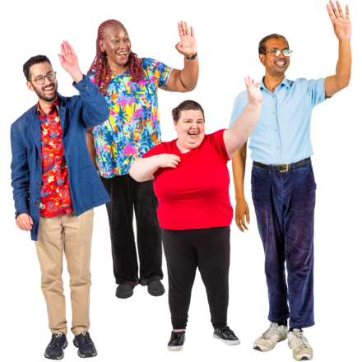 | We hope everyone enjoyed our event about friendship.  We will be having another online event.
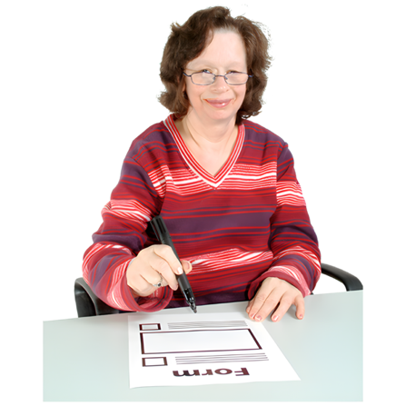 | If you want to come to our next event about transport for people with disability please register here: https://disabilitydialogue.com.au/events/transport/

