Invitation from the Disability Dialogue
Let’s talk about peer support

 | The Disability Dialogue wants you to come to a talk.
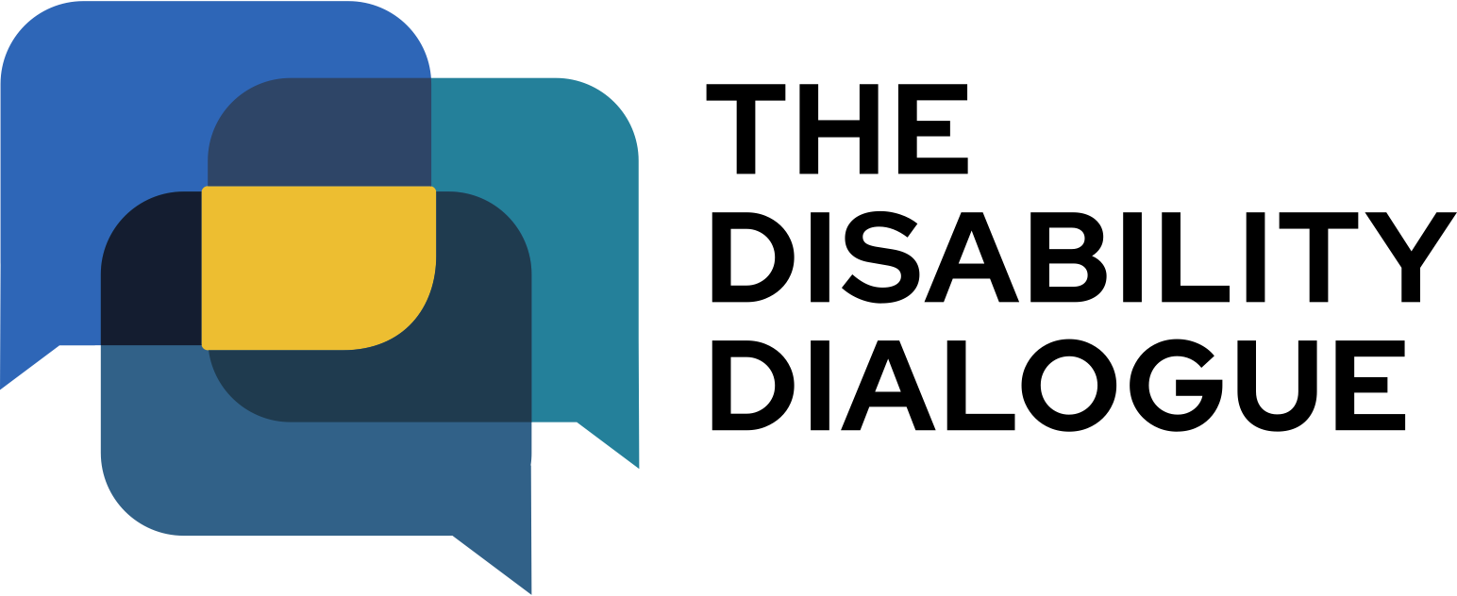 | The Disability Dialogue is a group of people who come together to talk about important things for people with disability.
 | The talk is about peer support.
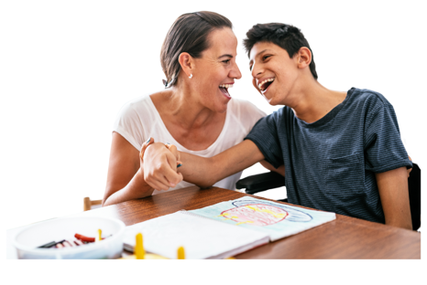 | Peer support is when people with an intellectual disability get together and give each other support and advice.  People help each other by sharing information or having fun together.
 | The talk is on Thursday, 19th June.
 | The time of the event is  - 1.00pm – 2.30 pm AEST (NSW, QLD, VIC, ACT, TAS)  - 12.30pm – 2.00pm (SA, NT)  - 11.00am – 12.30pm (WA)
 | The talk is online on Zoom.
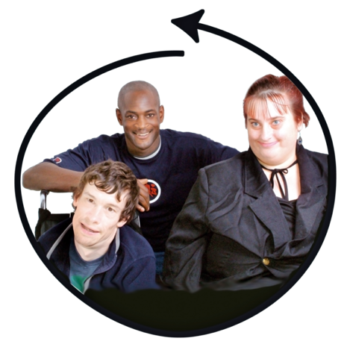 | This talk is for  - People with disability  - Their families  - Their support people  - Service providers  - People who care about people with disability
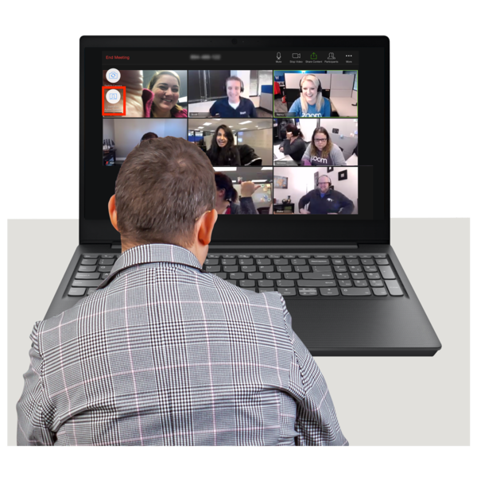 | If you would like to come to the talk please register here https://disabilitydialogue.com.au/events/connecting-to-community-peer-support/
 | After registering there is a survey which asks a few questions about peer support.  The survey is in Easy Read.
 | This survey will ask:  - If you have ever had peer support  - What you liked about peer support  - Would you be interested in doing peer support again.
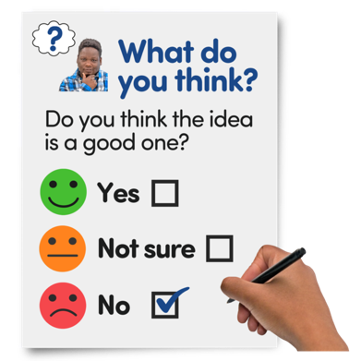 | You do not have to fill out the survey if you do not want to.
 | We will send you the Zoom link for the talk in an email after you register.  We will send you the link again the day before the talk.
 | If you have any questions about the talk please email  info@disabilitydialogue.com.au

