Summary of Disability Dialogue event on transport
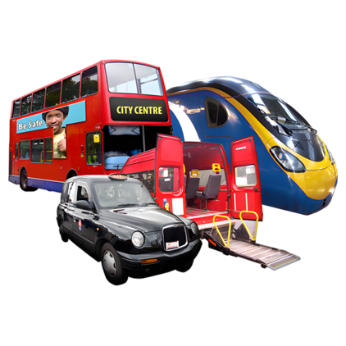 | The Disability Dialogue had an event about transport.
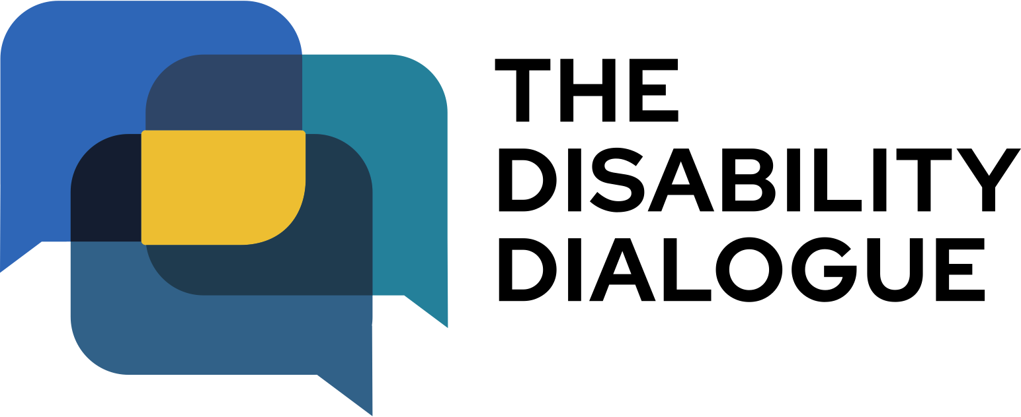 | The Disability Dialogue is a group of people who come together to talk about important things for people with disability.
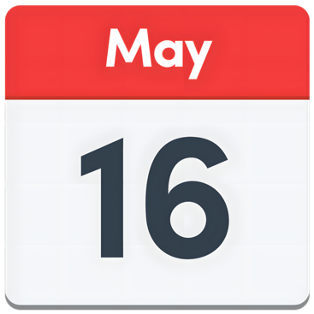 | The event was Friday 16th May.
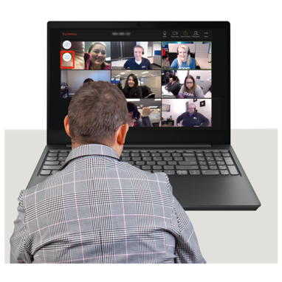 | You can watch the full recording of the event here: https://youtu.be/B0ZFlGp2uaA?feature=shared
The event order
  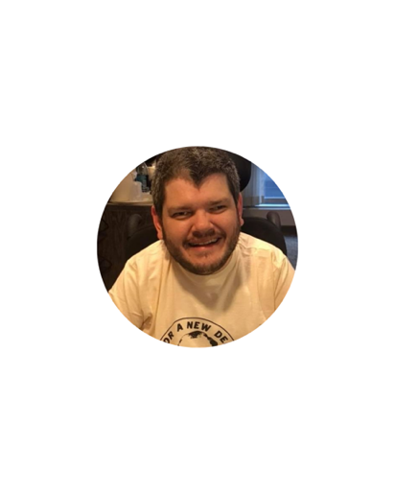  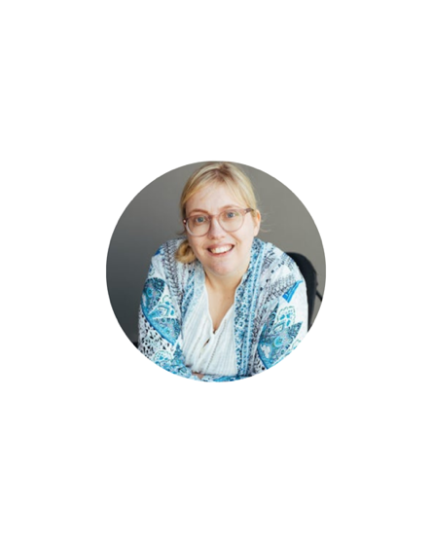  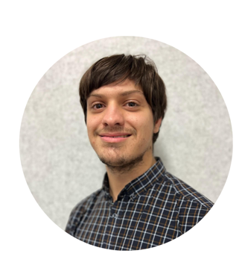 | The event started with a panel discussion between  - Elly Desmarchelier  - Todd Winther  - Emma Myers  - And Jake Simkus.  Elly, Todd, Emma and Jake are people with disability who were speakers at the event.
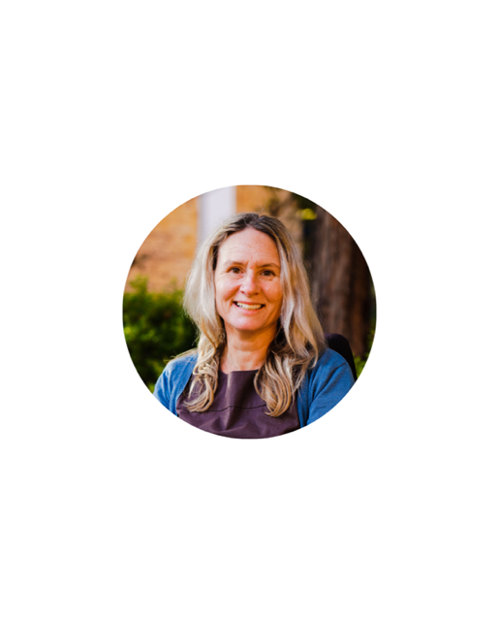 | Then Dr Lisa Stafford short speech about transport for people with disability.  Lisa is an expert in transport for people with disability.
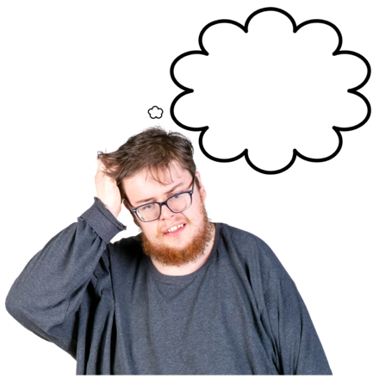 | Lisa said lots of people with disability think transport is hard to use.
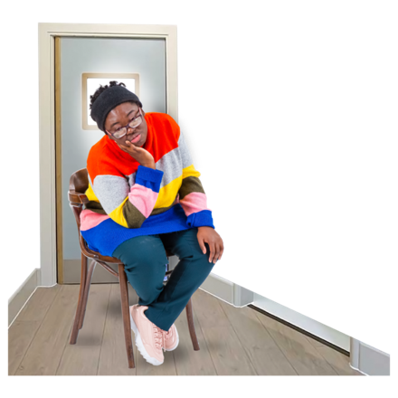 | This means lots of people with disability miss out on seeing doctors, taking shifts at work or seeing friends.
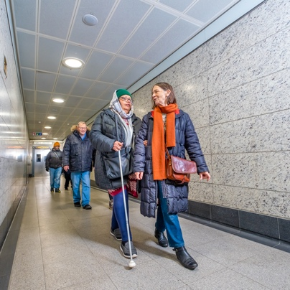 | Lisa said transport needs to be easier to use for everyone.
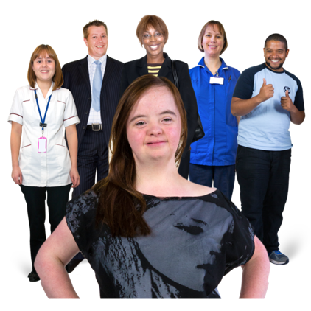 | All the speakers agreed transport needs to be fairer and safer to use.
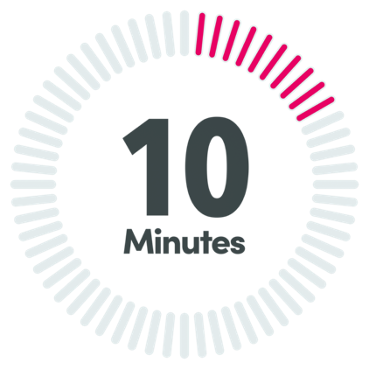 | Then there was a 10 minute break.
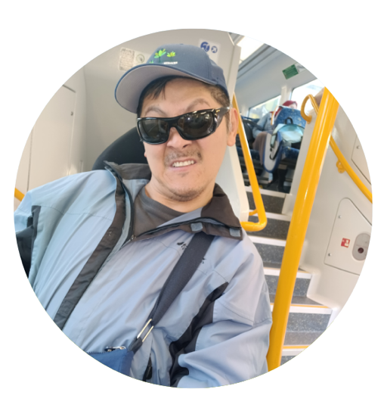 | After the break Quang Ngyuen and his support person Noah joined the talk.  Noah talked about how Quang helped make transport more accessible for his community.
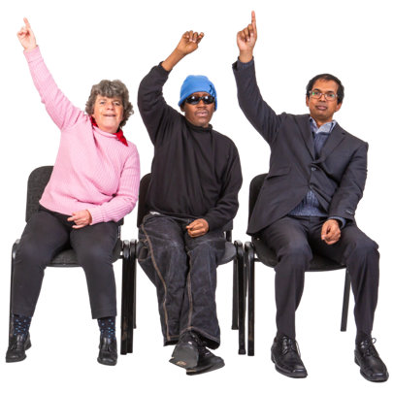 | We finished the event with questions from the audience that our panellists answered.

The next event
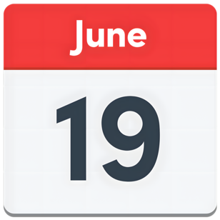 | The Disability Dialogue will have another event on Thursday 19th June.
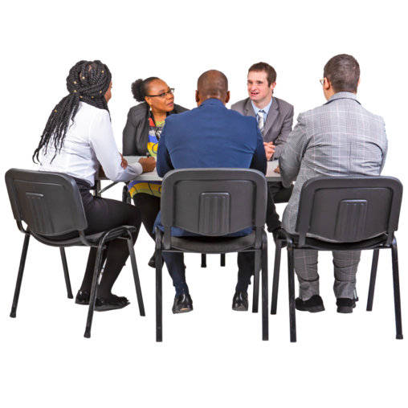 | The event will be about peer support.  Peer support is when people with intellectual disability get together to support each other, give advice and have fun.
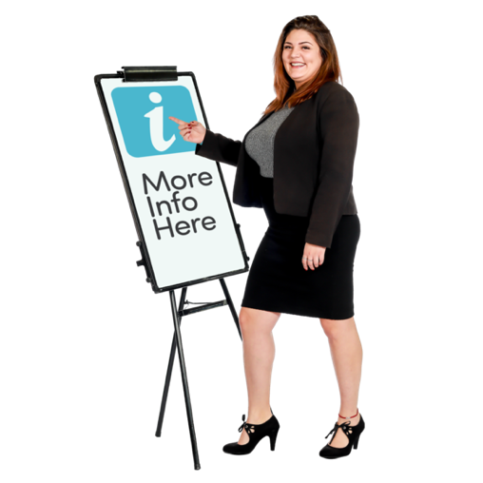 | You can learn more about this event by clicking this link: https://disabilitydialogue.com.au/events/connecting-to-community-peer-support/
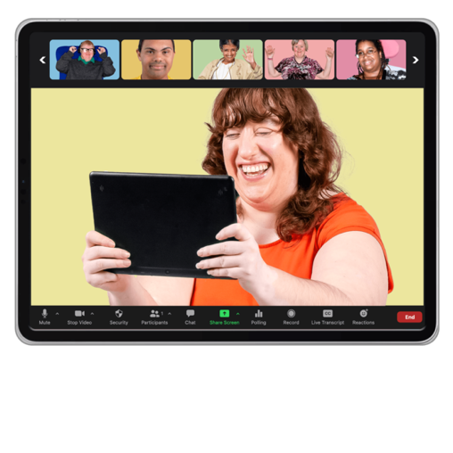 | We hope to see you there.

