RSVP for the Disability Dialogue event in September

 | The Disability Dialogue want you to come to a talk on Wednesday September 24th.
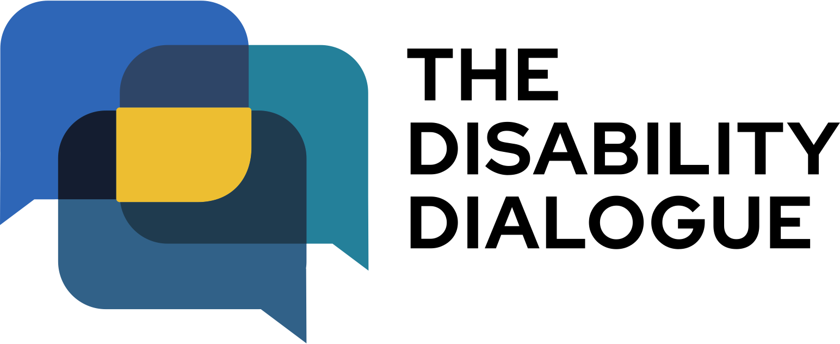 | The Disability Dialogue is a group of people who come together to talk about important things for people with disability.
 | The talk will be at:  - 1.00pm - 2.30pm (NSW, QLD, VIC, ACT, TAS)  - 12.30pm – 2.00pm (SA, NT)  - 11.00am – 12.30pm (WA)
 | The event is on Zoom.
 | We are still deciding what the talk will be about.
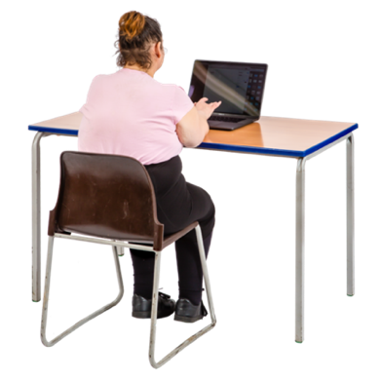 | Register and we will send you an email with more information about the event.
 | If you have any questions please email info@disabilitydialogue.com.au

