**Disability Dialogue event invitation**

**Foundations for a Good Life**

**The Disability Dialogue** wants you to come to a talk about getting support from places that are not the **NDIS**.

NDIS is the National Disability Insurance Scheme. NDIS gives some people with disability help to get the supports and services they need.



The Disability Dialogue is a group of people who come together to talk about important things for people with disability.

An image of Parliament House in Canberra.
The Australian Government is starting a new system of disability support called **foundational supports**.

Foundational supports are supports for people with disability that are not part of the NDIS.

The talk is about:

* What supports help you live a good life
* What supports that are not part of the NDIS would make life better
* How can disability support be easier to find
* How can information be more clear
* Who can help you find useful information

The talk is on Wednesday 30th July.

The talk will be online on Zoom.

The talk will be at:

* + - * 1.00pm – 2.30pm AEST (NSW, QLD, VIC, ACT, TAS).
      * 12.30pm – 2.00pm (SA, NT).
      * 11.00am – 12.30pm (WA).

This talk is for

* + - * + People with disability
        + Their families
        + Their support people
        + Service providers
        + People who care about people with disability.

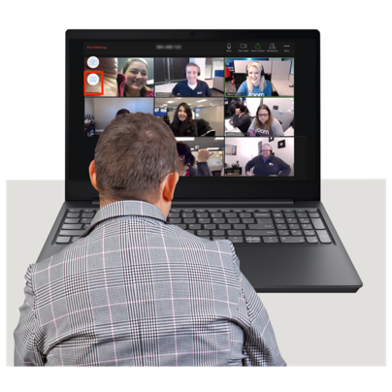

If you would like to come to the talk please register here <https://disabilitydialogue.com.au/events/gfs/>

|  |  |
| --- | --- |
|  | After registering there is a survey which asks a few questions.  The survey is in Easy Read. |

|  |  |
| --- | --- |
|  | You do not have to fill out the survey if you do not want to. |
|  | We will send you the Zoom link for the talk by email after you register.  We will send you the link again the day before the talk. |

If you have questions about this talk please email [info@disabilitydialogue.com.au](mailto:info@disabilitydialogue.com.au)