RSVP for the Disability Dialogue event in October

 | The Disability Dialogue want you to come to a talk on Wednesday October 22nd.
 | The Disability Dialogue is a group of people who come together to talk about important things for people with disability.
 | The talk will be at:  - 1.00pm - 2.30pm (NSW, VIC, TAS, ACT)  - 12.30pm – 2.00 (SA)  - 12.00 - 1.30pm (QLD)  - 10.30am - 12.00pm (NT)  - 10.00am - 11.30am (WA)
 | The event is on Zoom.
 | We are still deciding what the talk will be about.
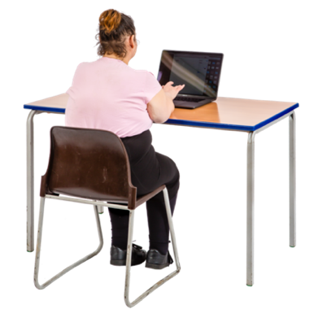 | Register and we will send you an email with more information about the event.
 | If you have any questions please email info@disabilitydialogue.com.au

