Disability Dialogue support for children with disability outside of the NDIS event summary
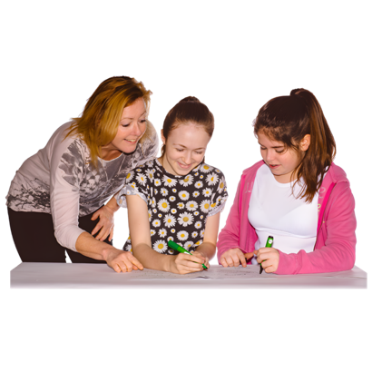 | The Disability Dialogue held an event about supports for children outside the NDIS on Monday 25th August.
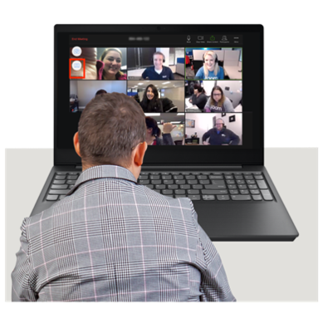 | You can watch a recording of the event here:  https://youtu.be/q5n-bQGCdFI

The event order
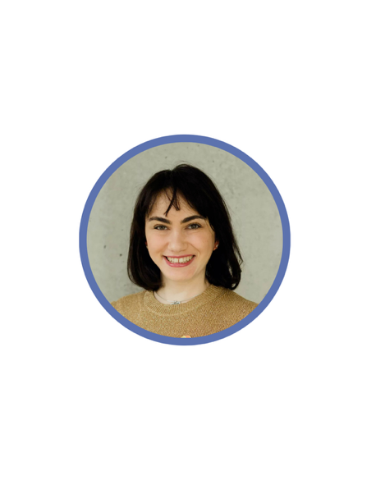  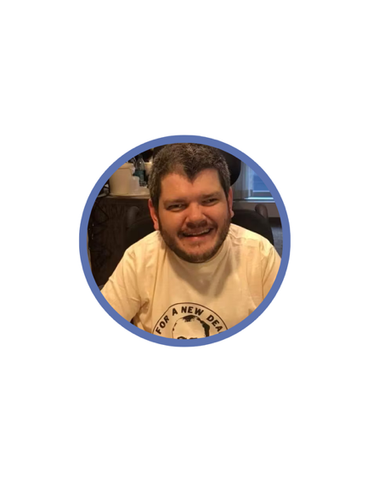 | Sara and Todd were the hosts of the event.  Sara is a writer.  Todd is an expert in disability support and the NDIS.
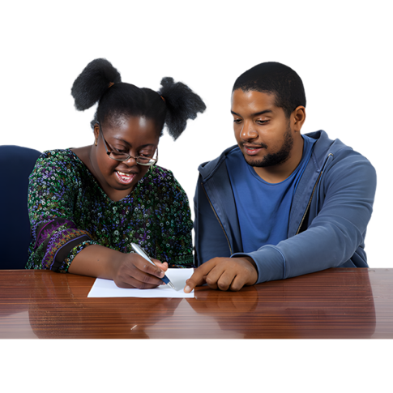 | Todd and Sara started by explaining what Targeted Foundational Support means.
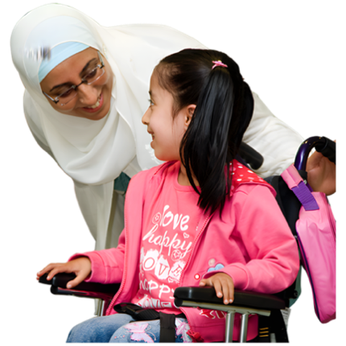 | Targeted foundational supports are supports for people with disability who do not get support from the NDIS.
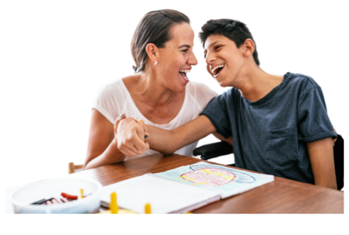 | NDIS is the National Disability Insurance Scheme.  NDIS gives some people with disability help to get the supports and services they need.
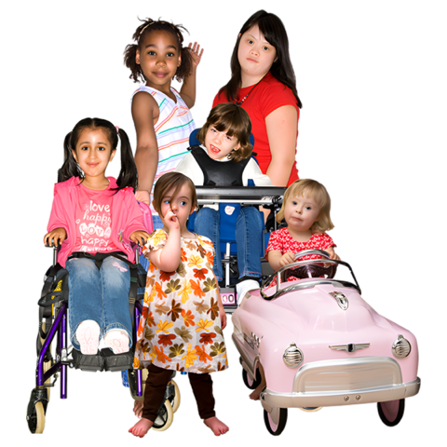 | This event was about targeted foundational supports for children.
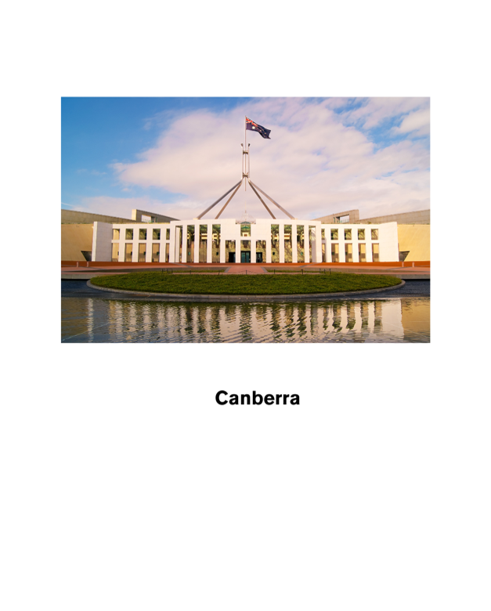 | Then Sara and Todd talked about the Federal Government’s Thriving Kids Program.
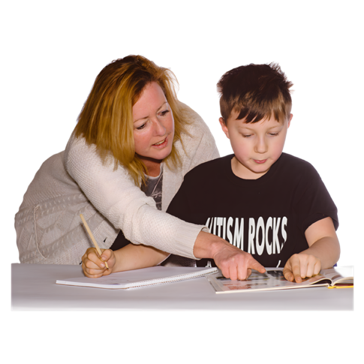 | The Thriving Kids Program is a new system that will give supports to children with learning disabilities and some children with autism.
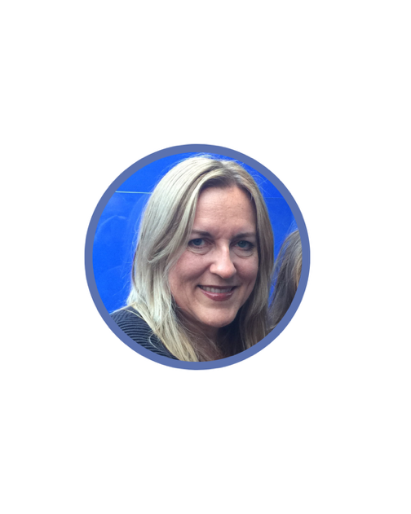  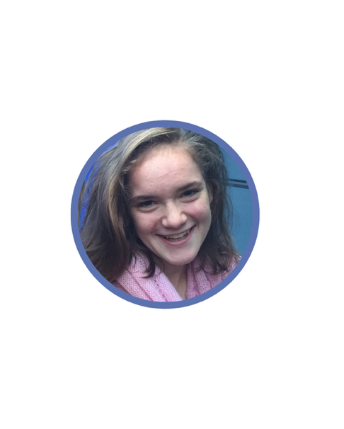 | Then Sarah and Stella Barton talked.  Sarah is Stella’s mum. She makes films about people with disability.  Stella has cerebral palsy and is a Paralympian.  This means she competes in the Olympics with people with physical or intellectual disability or people with low vision.
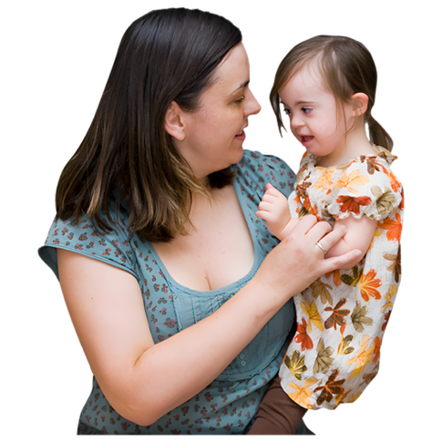 | Sarah talked about how hard it was to support her daughter before the NDIS existed.
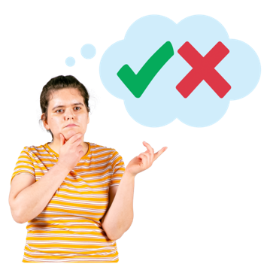 | Stella talked about how it is important to listen to kids and let them make their own decisions.
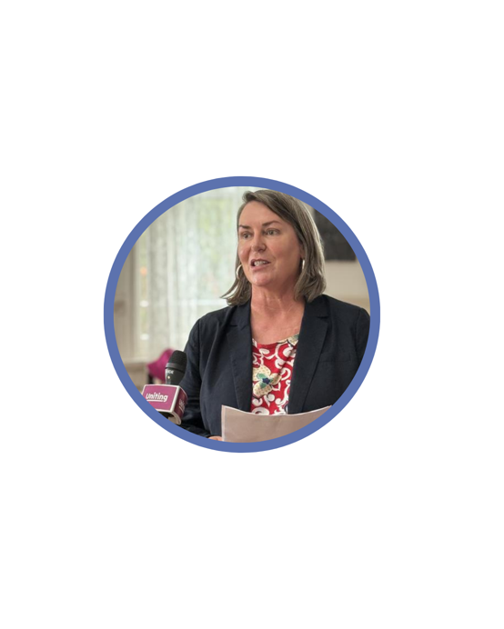 | Then Gretchen Young talked.  Gretchen is from the Secretariat of National Aboriginal and Islander Child Care.  We say SNAICC for short.
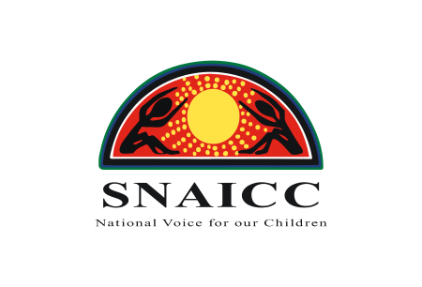 | SNAICC is the main group for Aboriginal and Torres Strait Islander children across Australia.
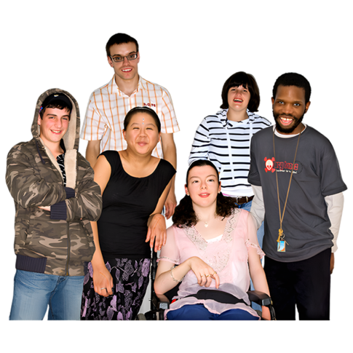 | Gretchen talked about why culturally safe support is important.
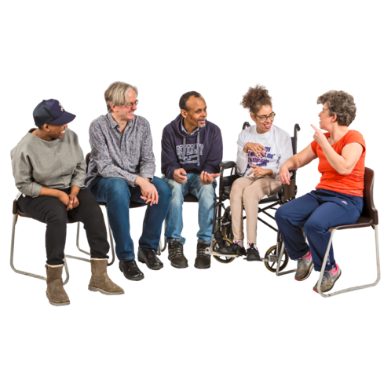 | Culturally safe support means:  - People feel safe.  - People feel respected.  - People feel like they belong in the community.
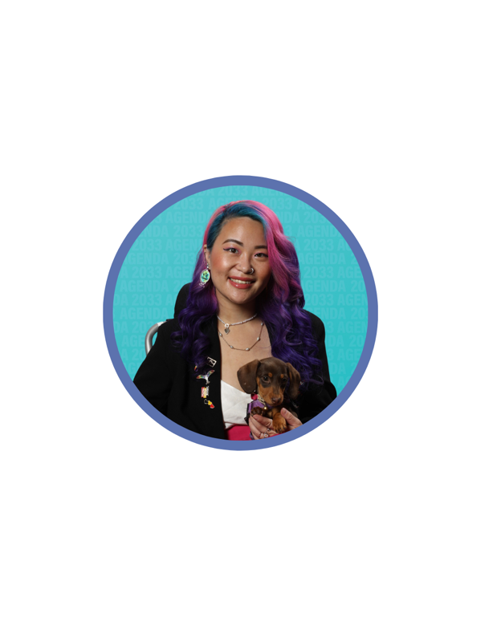 | Then Akii Ngo talked.  Akii uses they and them pronouns.  Akii talked about growing up with no support and no one understanding their culture.
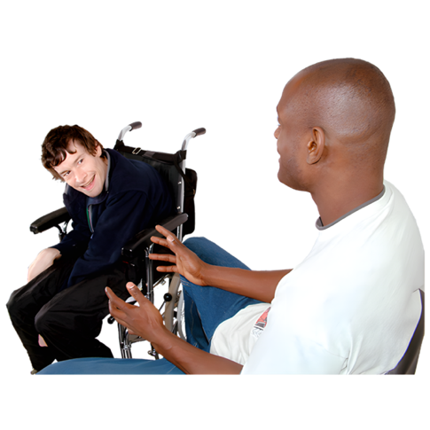 | Akii said it is important to share hard stories.  Sharing can help other people get the right support.
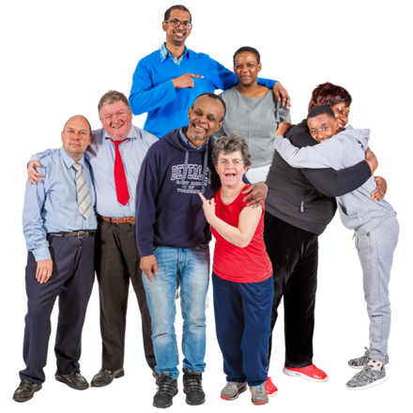 | They talked about how important it is to have a community.  They speak up for themselves because they feel safe and supported.
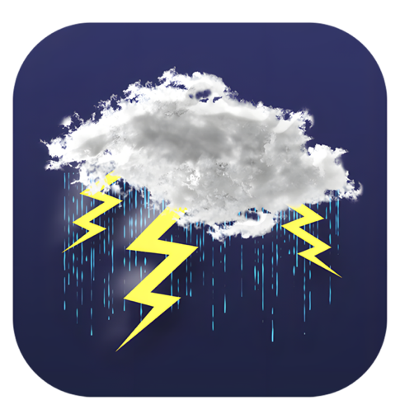 | The audience was also invited to the next event about how people with disability can stay safe during weather disasters.
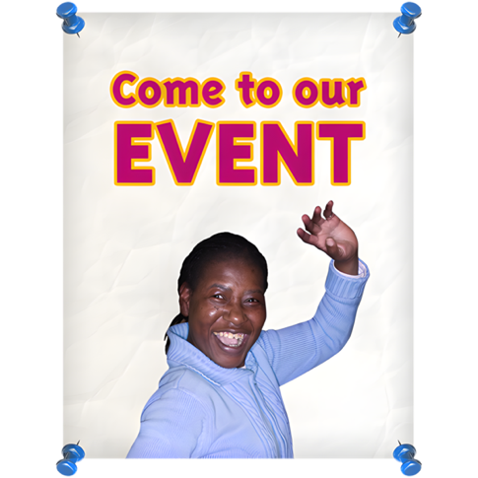 | RSVP to the next event here: https://disabilitydialogue.com.au/events/september_dialogue/

