Invitation from the Disability Dialogue:
How we prepare for weather disasters so people with disability can stay safe

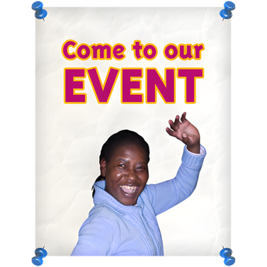 | The Disability Dialogue wants you to come to a talk.
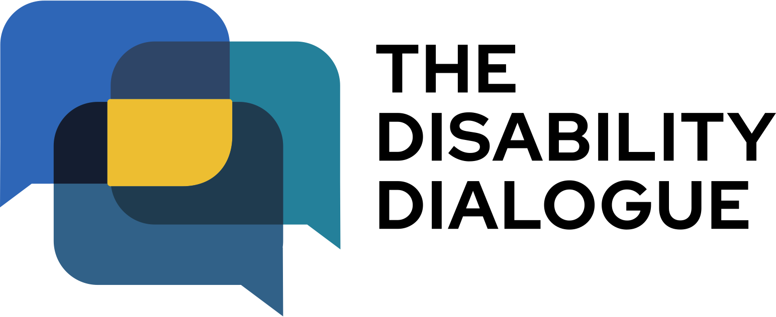 | The Disability Dialogue is a group of people who come together to talk about important things for people with disability.
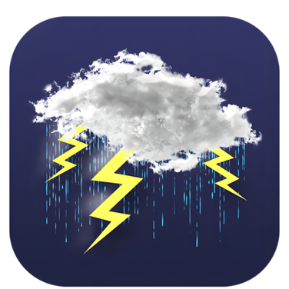 | The talk is about how people with disability can stay safe during weather disasters.
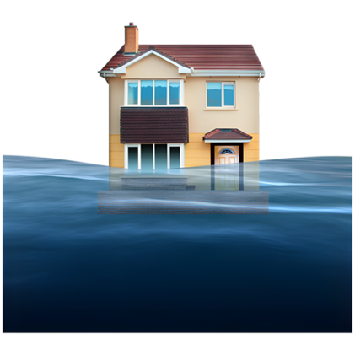 | Weather disasters include storms, floods, heatwaves, droughts and wildfires.
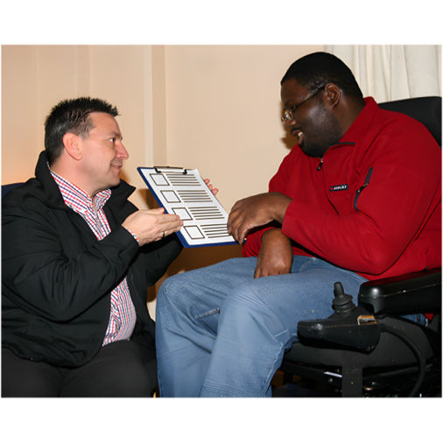 | Some of the questions we will ask at the talk are:  - How can people with disability stay safe during big storms, heatwaves and other weather disasters?  - How can people with disability feel prepared for weather disasters?  - What can we learn from other communities about how they handle weather disasters?
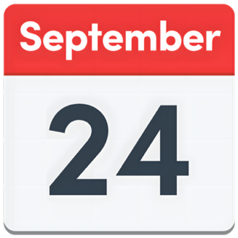 | The talk is on Wednesday 24th September.
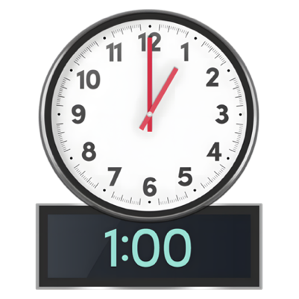 | The time of the talk is  - 1.00pm – 2.30 pm AEST (NSW, QLD, VIC, ACT, TAS)  - 12.30pm – 2.00pm (SA, NT)  - 11.00am – 12.30pm (WA)
 | The talk is online on Zoom.
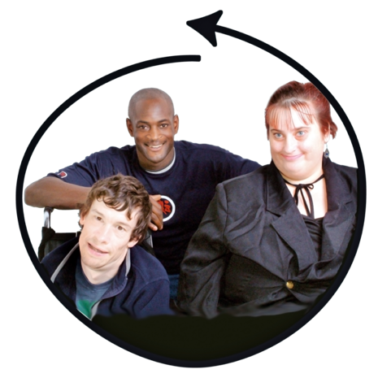 | This talk is for  - People with disability  - Their families  - Support people  - Service providers  - People who care about people with disability
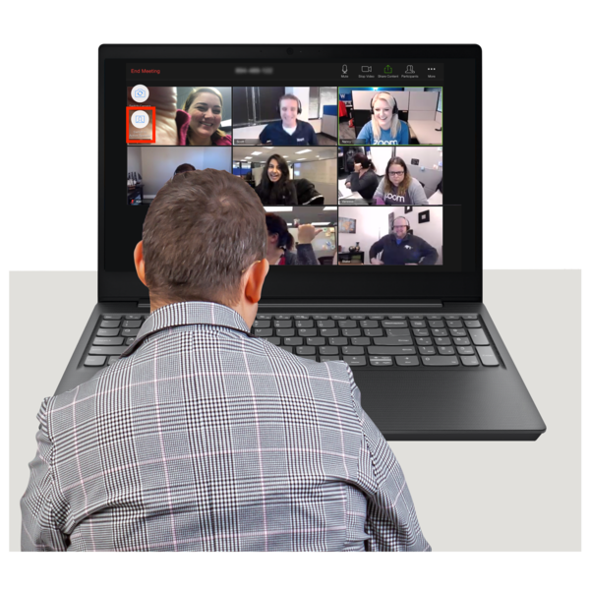 | If you would like to come to the talk please register here https://disabilitydialogue.com.au/events/september_dialogue/
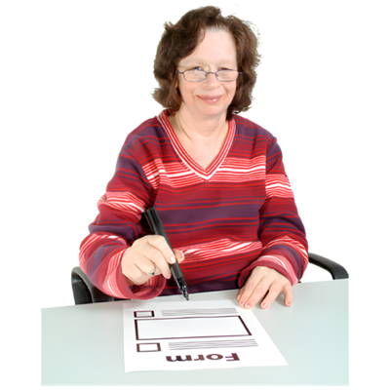 | After registering there is a survey which asks a few questions about how to help people with disability feel safe during weather disasters.  The survey is in Easy Read.
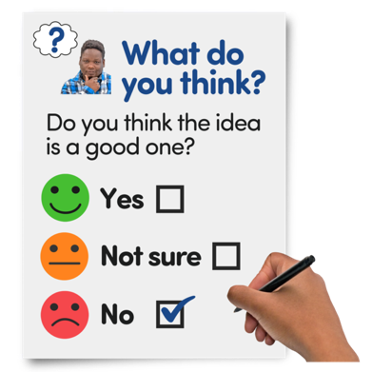 | You do not have to fill out the survey if you do not want to.
 | We will send you the Zoom link for the talk in an email after you register.  We will send you the link again the day before the talk.
 | If you have any questions about the talk please email  info@disabilitydialogue.com.au

