Disability Dialogue foundations for a good life event summary
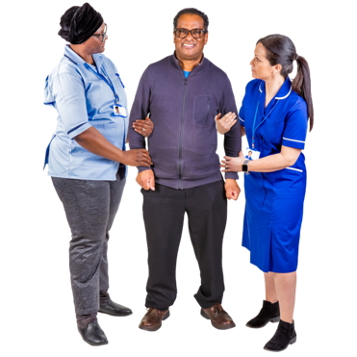 | The Disability Dialogue held an event about supports outside the NDIS on Wednesday 30th July.
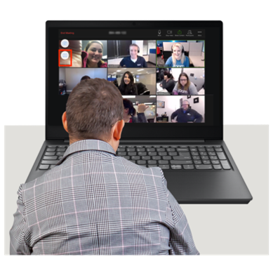 | You can watch a recording of the event here:  https://youtu.be/kmlJ2MQSgyw

The event order
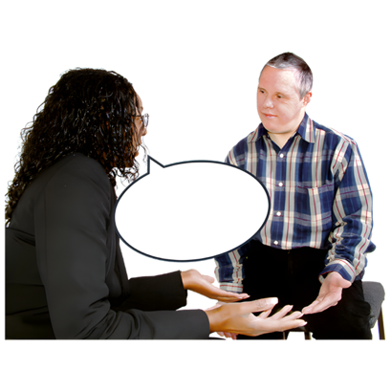 | The event started by explaining what General Foundational Supports means.
 | General foundational supports are supports that are outside the NDIS.
  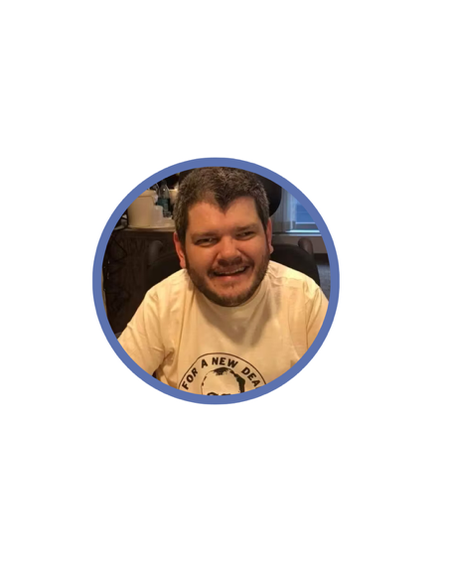 | Sara and Todd were the hosts of the event.
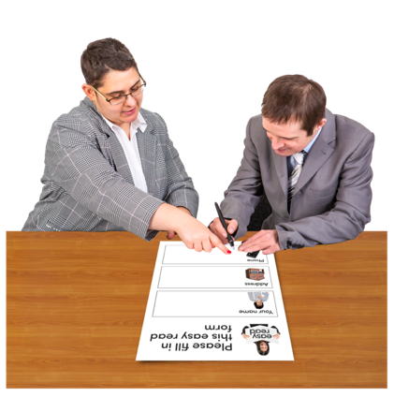 | Sara and Todd started the event by talking about three different types of supports.  - Mainstream services  - Supports from the NDIS  - Foundational supports
 | Each of these supports are different but they all help people to live a better life.
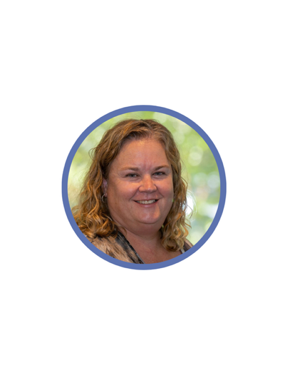  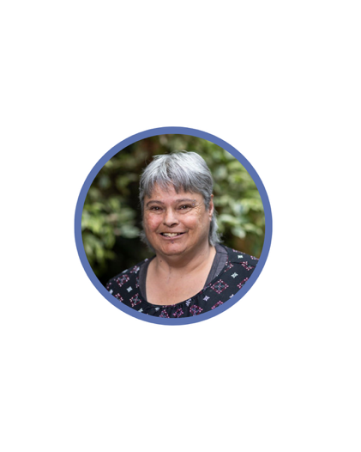 | Catherine McAlpine from Inclusion Australia talked with Sonia Hume.  Sonia is a self-advocate and member of Speak Out which is a group that supports people with intellectual disability to know their rights.
 | Sonia talked about how she learned to speak up for herself and know her rights.  It takes a long time to build confidence and gain skills.
 | Todd talked to Katrina from VALID which is a group for adults with intellectual disability.  They talked about why good information and talking to people you trust is important before making big decisions.
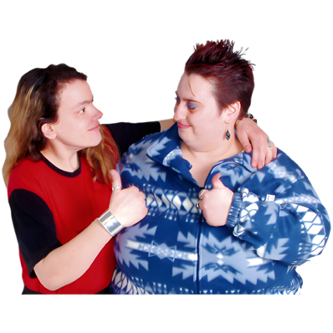 | Todd and Sara also talked about the importance of peer support to find people to trust and talk to.  Peer support is when people help each other by sharing information or learning from each other.
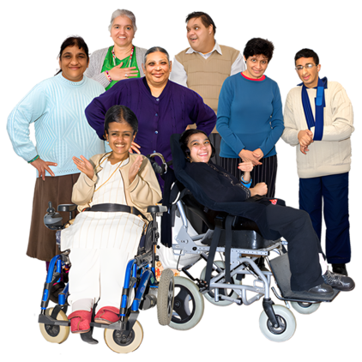 | Everyone agreed that we need more money for foundational supports like  - Clear and useful information  - Advocacy  - Capacity building which means learning new skills and building confidence  - Peer support  - Making decisions
 | At the end of the event our speakers answered some questions from the audience.

