Disability Dialogue weather-related disasters event summary
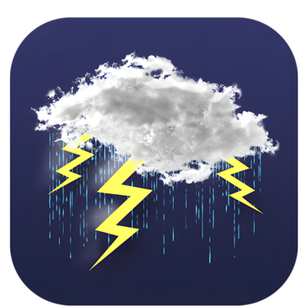 | The Disability Dialogue held an event about how people with disability can stay safe during weather-related disasters.  Weather-related disasters are floods, heatwaves, droughts and wildfires.
 | The event was on Wednesday 24th September.
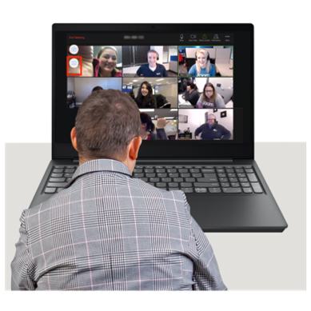 | You can watch a recording of the event here:  https://youtu.be/mrdVkOZHAdQ?feature=shared

The event order
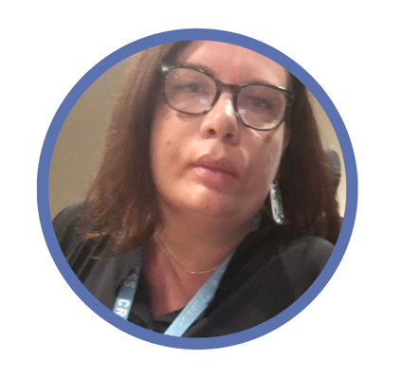   | Kelly Griffis-Cox and Andrew Fairbairn were the hosts of the event.  Kelly is a disability advocate and works with the Disability Dialogue.  Andrew works for Limbs for Life which provides peer support and training for people with disability.
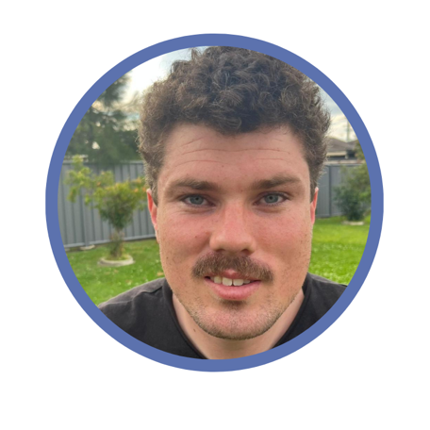 | Jonathan Tracey spoke first.  He talked about his experience during the Lismore floods in 2022 and how he saved his family.
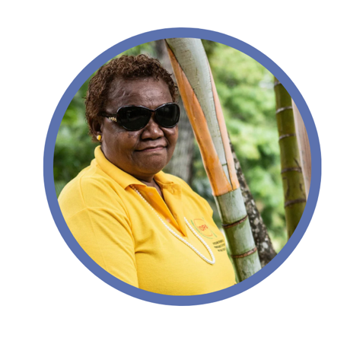 | Nelly Caleb was supposed to talk next but she was not able to attend the event.  Nelly lives in Vanuatu and helps people with disability be prepared for weather-related disasters.
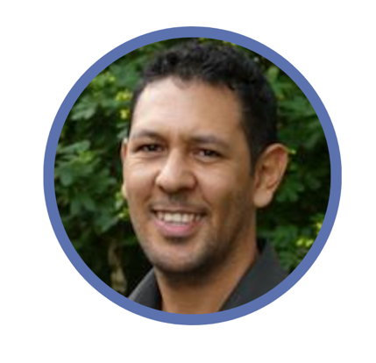 | Then Joseph Archibald talked.  Joseph helps Aboriginal and Torres Strait Islander people get the support they need.
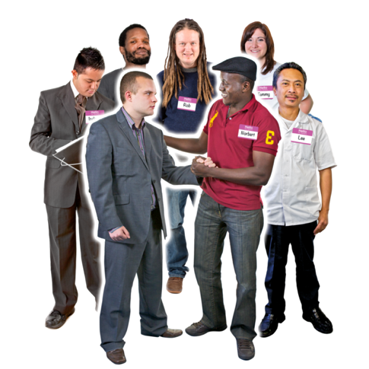 | Joseph talked about what he has learned about providing services to Aboriginal and Torres Strait Islander people with disability.
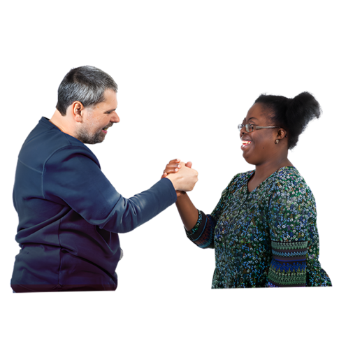 | He also talked about how important it is for service providers to build trust with Aboriginal and Torres Strait Islander people.
 | The event ended with all the speakers answering questions from the audience.
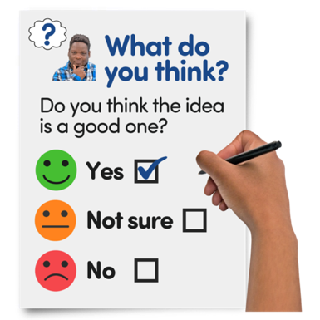 | You can complete a survey about the event if you want to.  You can do the survey here https://www.rixeasysurvey.org/kiosk/Z7Qy
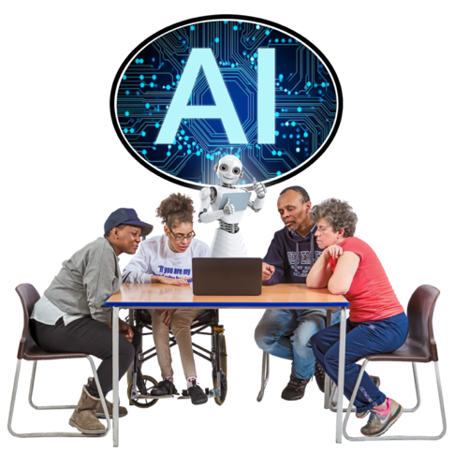 | The audience was also invited to the next even which will be about artificial intelligence.
 | Artificial intelligence is when computers or machines are made to think and learn like people.
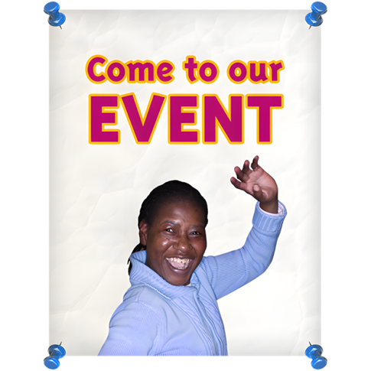 | RSVP to the next event here https://disabilitydialogue.com.au/events/october-open-dialogue/

