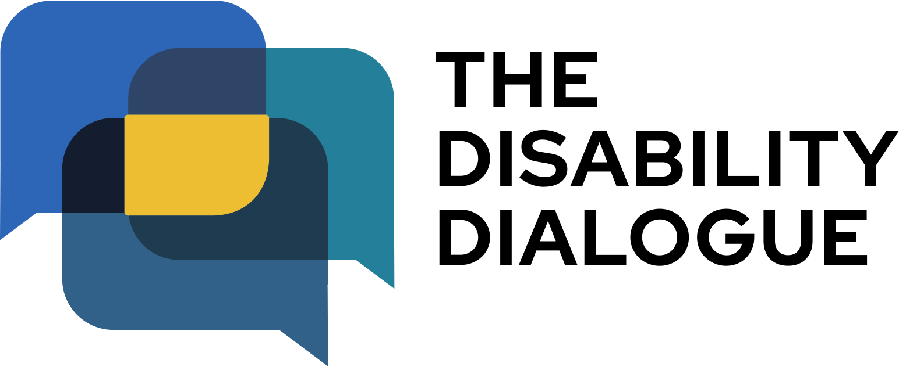

Disability Dialogue Artificial Intelligence event summary

About the event…………………………………..2
The event order…………………………………..4

About the event
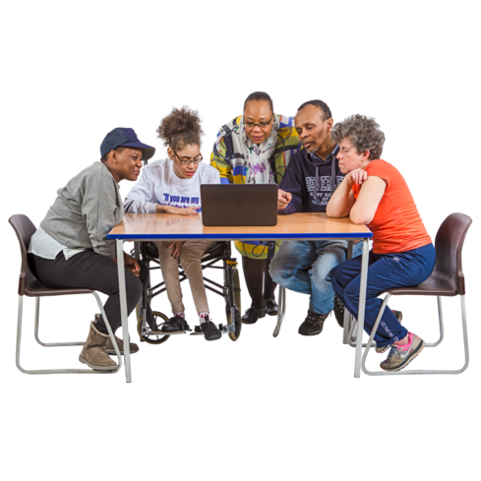 | The Disability Dialogue held an event about how artificial intelligence is changing our lives.
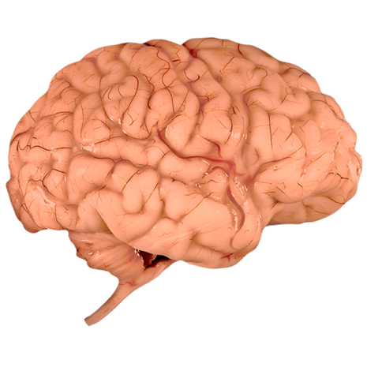 | Artificial intelligence is when computers or machines are made to think and learn, a bit like people.  We say AI for short.
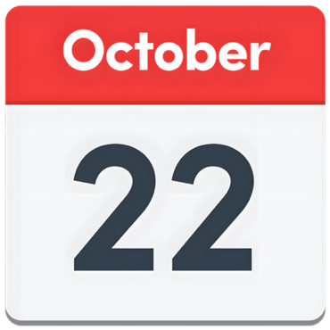 | The event was on Wednesday 22nd October.
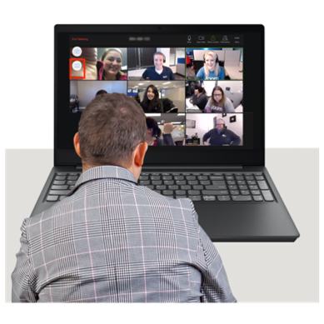 | You can watch a recording of the event here: https://youtu.be/dn2gq707-5s?si=aM9AarMU4hSAr0SK

The event order
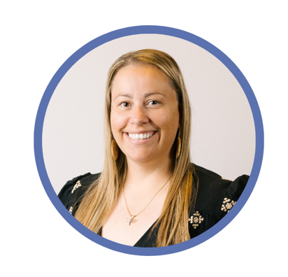 | Carly Wallace welcomed everyone to the event.  Carly is the Director of the Disability Dialogue.
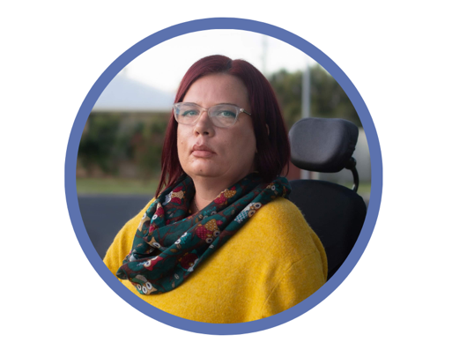  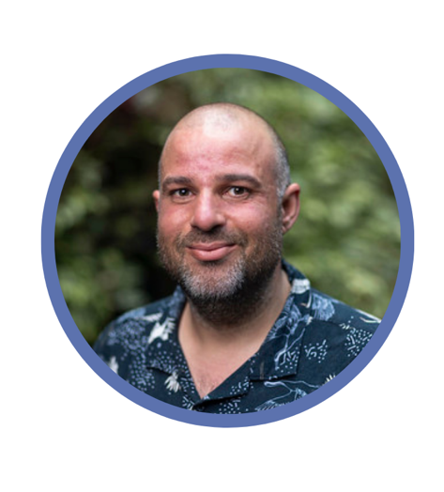 | Kelly Griffis-Cox and Sam Mouakkassa were the hosts of the event.  Kelly is a disability advocate and works with the Disability Dialogue.  Sam works for the Victorian Advocacy League for Individuals with Disability.
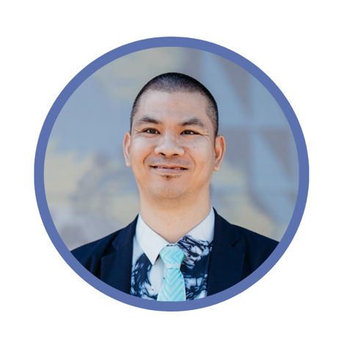 | Sisaleo Philavong spoke first.  He talked about how he uses AI in his work to translate things for people who do not speak English.
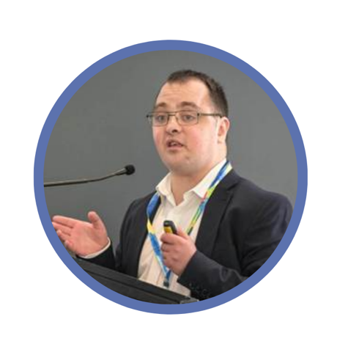 | Zac Colton and Jon Paior spoke next.  Zac has an intellectual disability and tells people about Apps you can use to make things easier to understand.  Apps is short for Applications.
 | Zac uses ones like Chat GPT or the Make it Easy App.
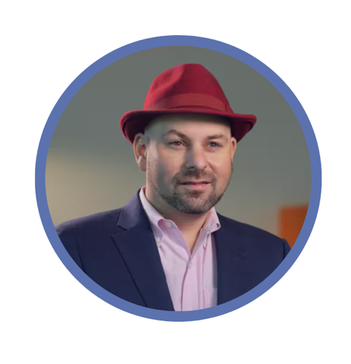 | Jon is an expert in cyber security, which means he helps keep everyone’s personal information safe on the internet.
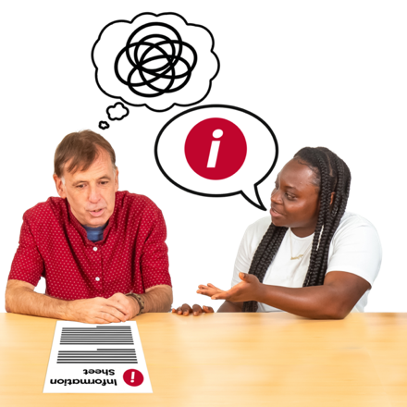 | Zac and Jon talked about how some Apps help make things easier to understand.
 | Some Apps turn things into Easy Read and plain English.  You can use Apps for  - Understanding recipes  - Reading menus  - Doctor’s notes  - Translations
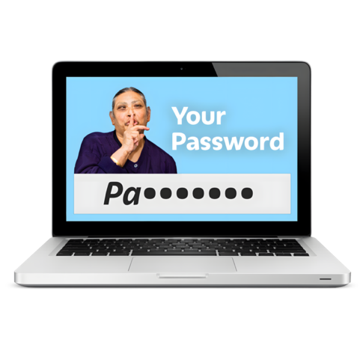 | Zac and Jon also talked about how to stay safe while using AI by never sharing any personal information.
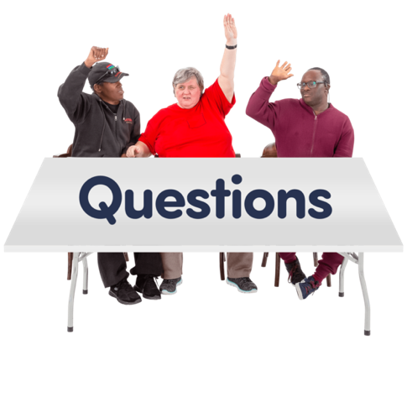 | The event ended with all the speakers answering questions from the audience.
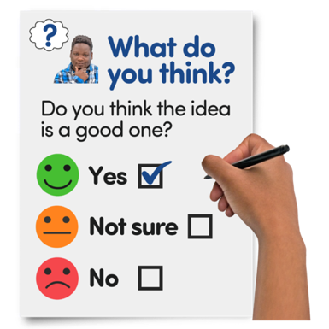 | You can complete a survey about the event if you want to.  You can do the survey here https://www.rixeasysurvey.org/kiosk/ap4M
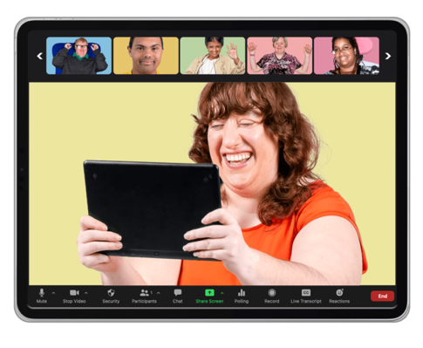 | The audience was also invited to the next event which will be the last event of the year.
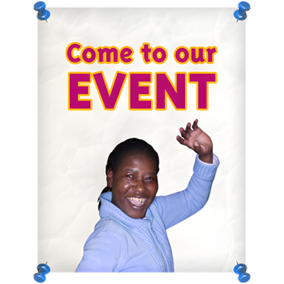 | RSVP to the next event here https://disabilitydialogue.com.au/events/november-dialogue/

