Invitation from the Disability Dialogue:
How AI is changing our lives.

 | The Disability Dialogue wants you to come to a talk.
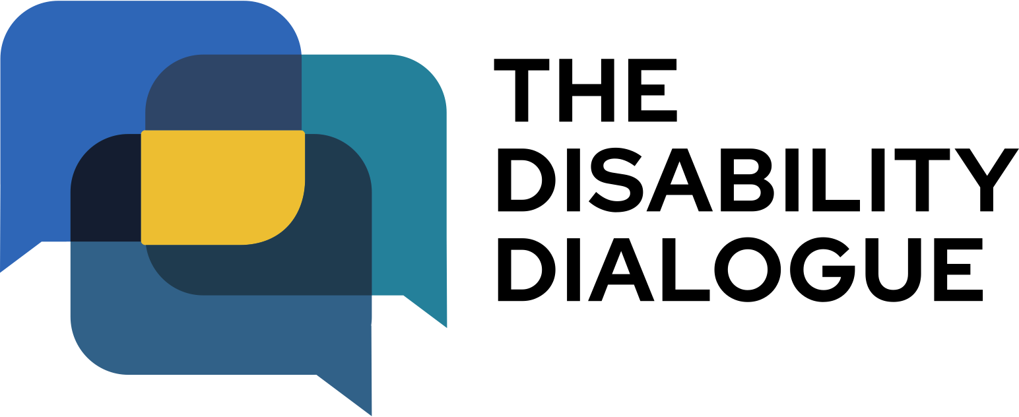 | The Disability Dialogue is a group of people who come together to talk about important things for people with disability.
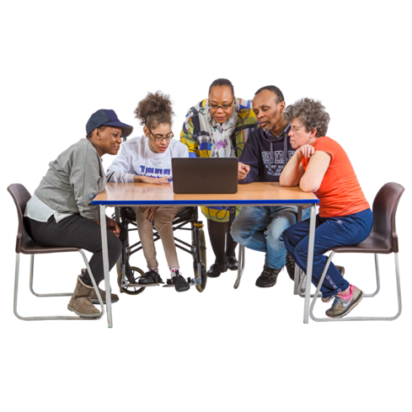 | The talk is about how artificial intelligence or AI may change the lives of:  - people with disability  - their families  - people who support them.
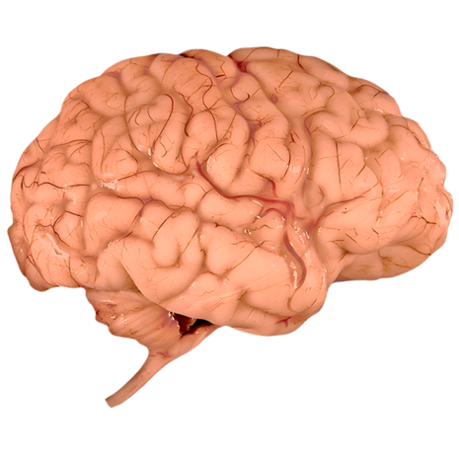 | AI is computer technology that learns from information and helps people by giving answers or doing tasks for them.
 | For example:  - Answering questions  - Setting reminders  - Meal planning.
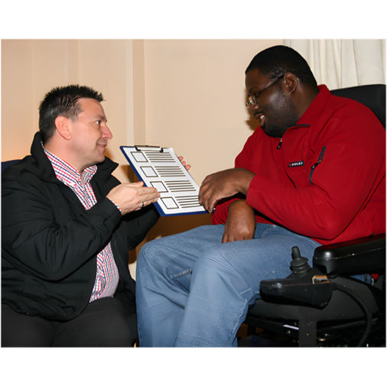 | Some of the questions we will ask at the talk are:  - How can we use AI to make our lives better?  - How can we stay safe while using AI?
 | The talk is on Wednesday 22nd October.
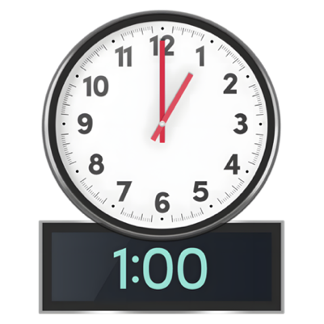 | The time of the talk is  - 1.00 pm – 2.30 pm AEDT (NSW, VIC, ACT, TAS)  - 12.30 pm – 2.00pm (SA)  - 12.00 pm – 1.30 pm (QLD)  - 11.30 am – 1.00 pm (NT)  - 10.00 am – 11.30am (WA).
 | The talk is online on Zoom.
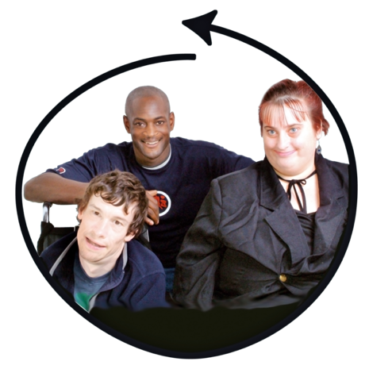 | This talk is for  - People with disability  - Their families  - Support people  - Service providers  - People who care about people with disability.
 | If you would like to come to the talk please register at  https://disabilitydialogue.com.au/events/october-open-dialogue/
 | After registering there is a survey which asks a few questions about how people with disability can use AI.  The survey is in Easy Read.
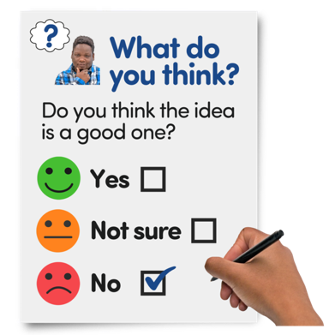 | You do not have to fill out the survey if you do not want to.
 | We will send you the Zoom link for the talk in an email after you register.  We will send you the link again the day before the talk.
 | If you have any questions about the talk please email  info@disabilitydialogue.com.au

