RSVP for the Disability Dialogue event in March

 | The Disability Dialogue is hosting an event on Wednesday March 25th.
 | The Disability Dialogue is a group of people who come together to talk about important things for people with disability.
 | The talk will be at:  - 1.00pm - 2.30pm (NSW, VIC, ACT, TAS)  - 12.30pm – 2.00pm (SA)  - 12.00pm – 1.30pm (QLD)  - 11.30am – 1.00pm (NT)  - 10.00am – 11.30am (WA)
 | The event is on Zoom.
 | We are still deciding what the topic will be.
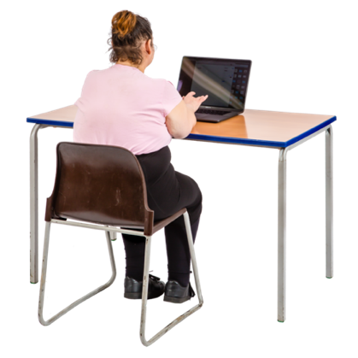 | Register today and we will send you an email with more information about the event.
 | You can register here https://disabilitydialogue.com.au/events/march-open-dialogue/
 | If you have any questions please email info@disabilitydialogue.com.au

