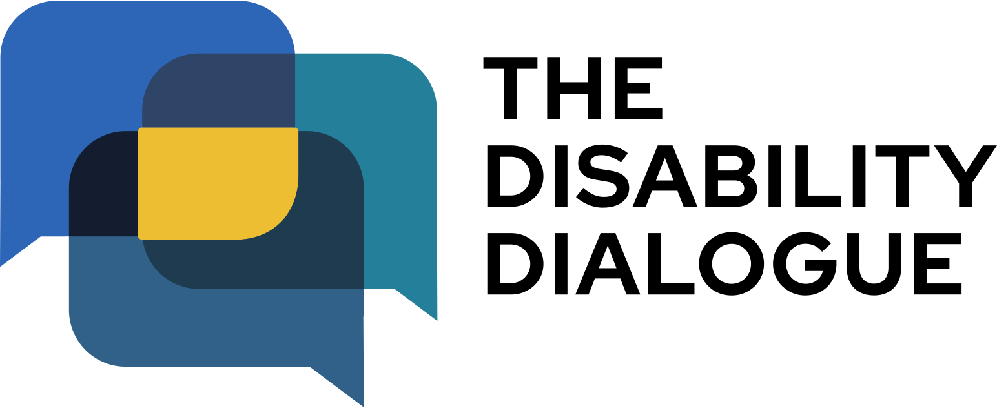

Open Dialogue event summary:

What happened in 2025 for people with disability? A year in review.

Contents

About the event…………………………………..3
What happened at the event…..………………..4

About the event
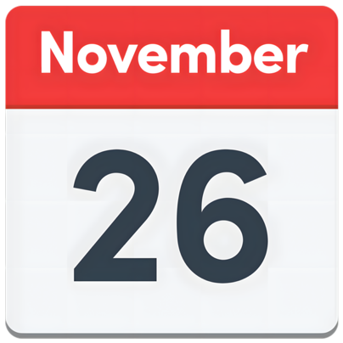 | The Disability Dialogue held its last event for 2025 on Wednesday 26th November.
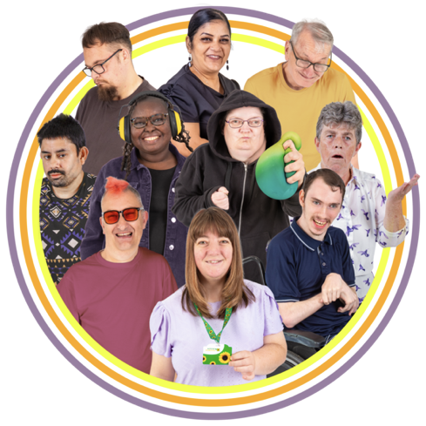 | The event was about some of the biggest things that happened this year for people with disability and their community.
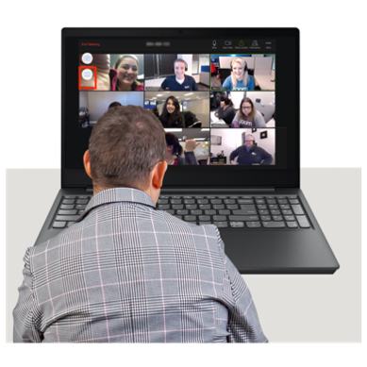 | You can watch a recording of the event here: https://disabilitydialogue.com.au/events/november-dialogue/

What happened at the event
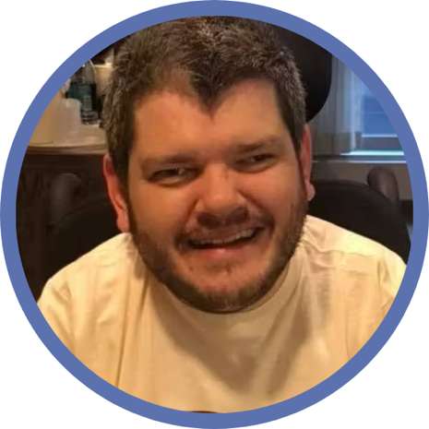 | Todd Winther welcomed everyone to the event.  Todd is a disability policy expert.  This means he knows a lot about disability rules and laws and how they work.
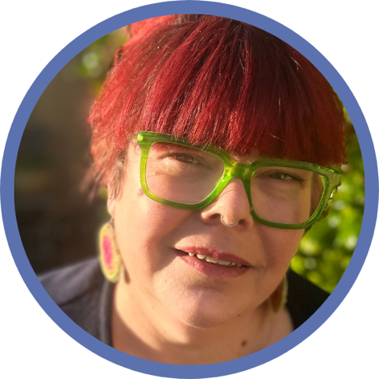 | Todd hosted the event with Kelly Treloar.  Kelly is a disability advocate and works with the Disability Dialogue.
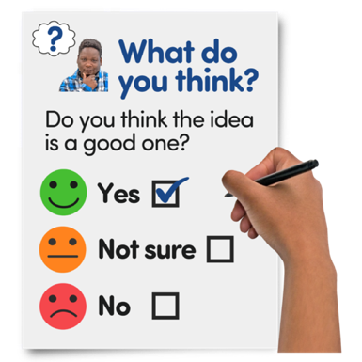 | Todd and Kelly talked about the survey people filled in before the event.  The survey asked people how they felt about 2025 for people with disability and their community.  Most people said the year was a mix of good and bad.
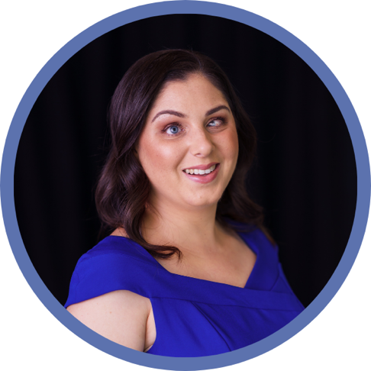 | Nas Campanella talked about the biggest news stories she wrote for the ABC this year.  Nas is an ABC reporter who writes stories about people with disability.
 | Nas talked about the news stories she wrote about problems with the National Disability Insurance Scheme or NDIS
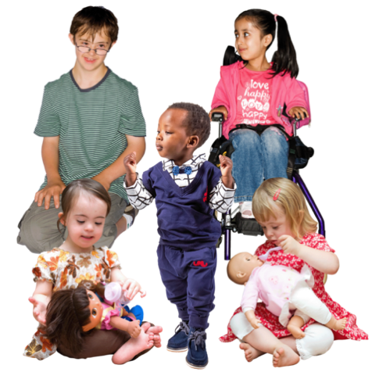 | Nas also talked about some of the good things she did this year.  For example  - Writing a news story about new playgroups for deaf children  - Writing an accessible picture book.
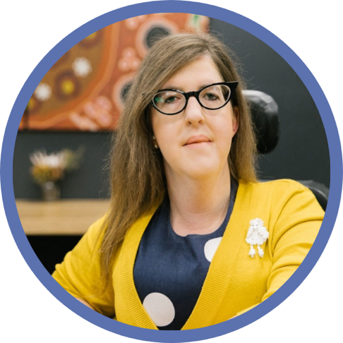 | Natalie Wade from the NDIS Quality and Safeguards Commission spoke about what it is like to have an important job like hers as a person with disability.
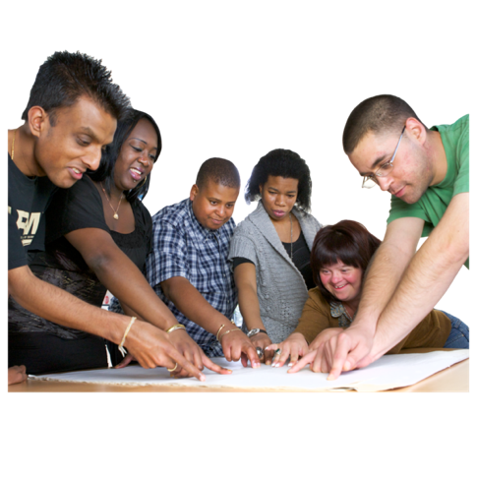 | The NDIS Quality and Safeguards Commission makes sure NDIS supports and services are  - Fair  - Follow the rules and laws.
 | Natalie also talked about some of the big projects she worked on in 2025 like the Disability Action Plan.
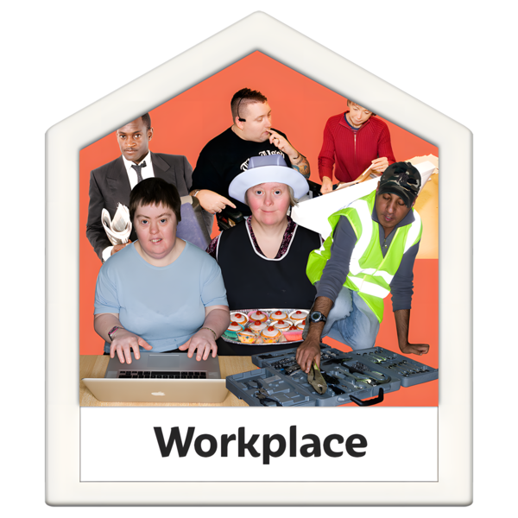 | The Disability Action Plan makes sure places that people with disability work are inclusive.
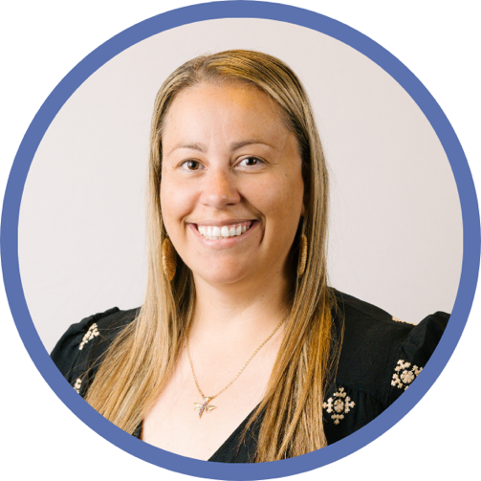 | Carly Wallace talked about what the Disability Dialogue will be doing next year.
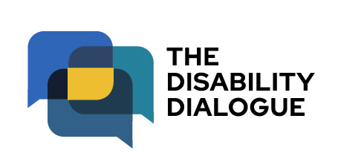 | Carly is the Director of the Disability Dialogue.  She talked about the Feature Dialogue.
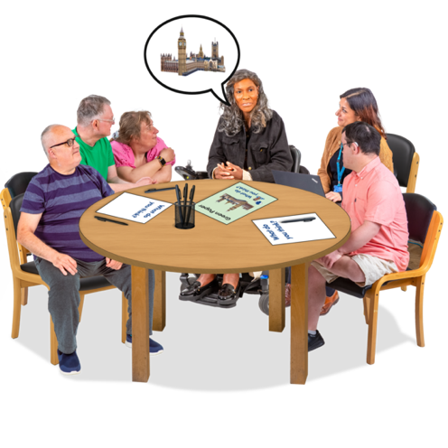 | The Feature Dialogue is a new project where people with disability get together to talk about ways to fix problems people with disability face.
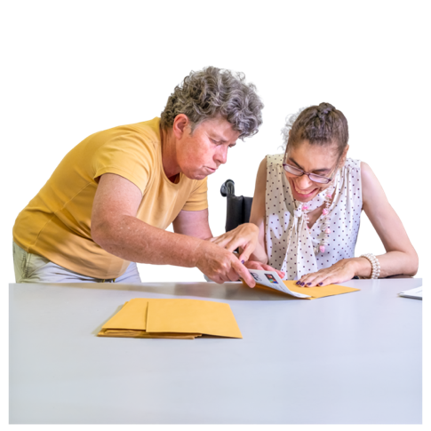 | The first Feature Dialogue will be about foundational supports.  Foundational supports are services and supports for people with disability that are not on the NDIS.
Carly invited people to be a part of the Feature Dialogue.

Feature Dialogue sessions will be held each month on Zoom for 6 months.

You will get paid for going to Feature Dialogue sessions.

 | You can get more information about the Feature Dialogue at:https://disabilitydialogue.com.au/projects/feature-dialogue-foundations/
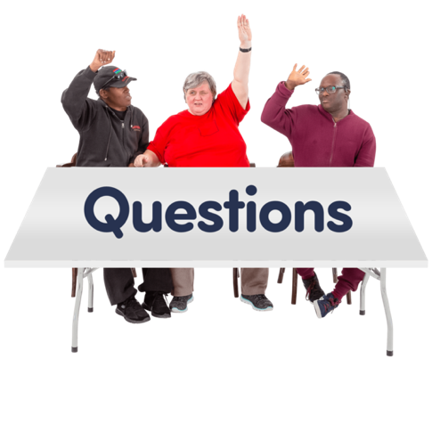 | Carly also answered some questions from the audience.
You can fill in an Easy Read survey to tell us what you thought about the event at:

https://www.rixeasysurvey.org/kiosk/a399

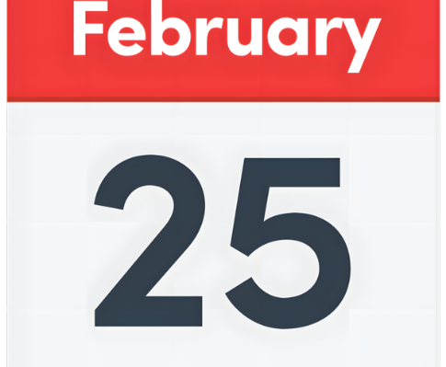 | The next Disability Dialogue event will be on 25 February 2026.
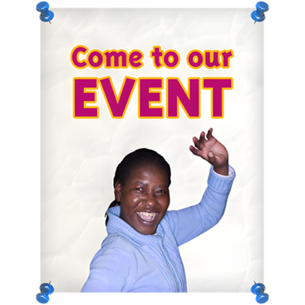 | You can sign up to the next event at:  https://disabilitydialogue.com.au/events/november-dialogue/

