Invitation from the Disability Dialogue:
High school, university and TAFE for young people with disability

 | The Disability Dialogue wants you to come to a talk.
 | The Disability Dialogue is a group of people who come together to talk about important things for people with disability.
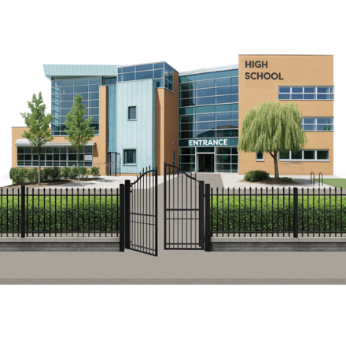 | The talk is about education for young people with disability who are in high school, university or TAFE.
 | Young people with disability can have a hard time with high school, university or TAFE because the schools don’t have what people with disability need to do their best.
 | We will talk about what makes education hard for people with disability.
 | We will also talk about what helps young people with disability have a good experience at school.
 | The talk is on Wednesday 25th February.
 | The time of the talk is  - 1.00 pm – 2.30 pm AEDT (NSW, VIC, ACT, TAS)  - 12.30 pm – 2.00pm (SA)  - 12.00 pm – 1.30 pm (QLD)  - 11.30 am – 1.00 pm (NT)  - 10.00 am – 11.30am (WA).
 | The talk is online on Zoom.
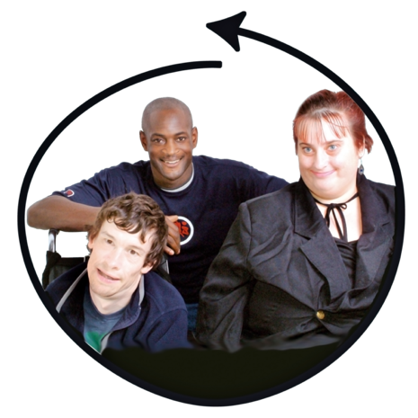 | This talk is for  - People with disability  - Their families  - Support people  - Service providers  - People who care about people with disability.
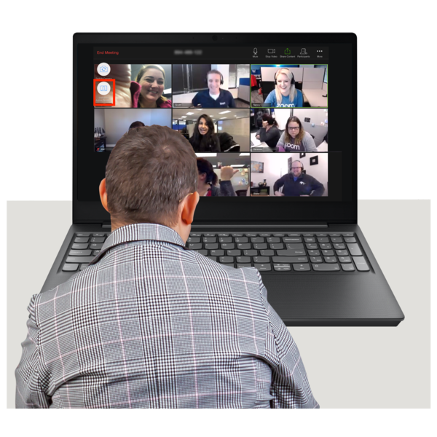 | If you would like to come to the talk please register at https://disabilitydialogue.com.au/events/save-the-date-for-the-february-open-dialogue/
 | After registering there is a survey which asks a few questions about what you think is important for students to do well in school.  The survey is in Easy Read.
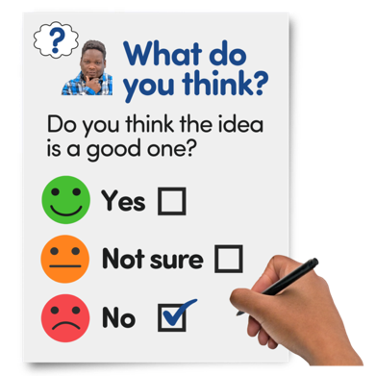 | You do not have to fill out the survey if you do not want to.
 | We will send you the Zoom link for the talk in an email after you register.  We will send you the link again the day before the talk.
 | If you have any questions about the talk please email  info@disabilitydialogue.com.au

