Invitation from the Disability Dialogue
Equal education for teens and young adults with disability



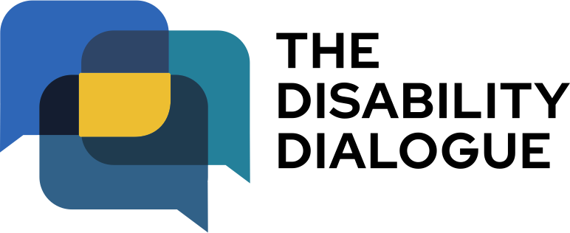



The Disability Dialogue wants you to come to a talk.

The Disability Dialogue is a group of people who come together to talk about important things for people with disability.

The talk is about education for teenagers and young adults with disability.

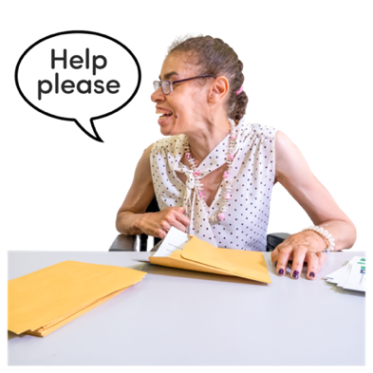







Many teenagers and young adults with disability do not feel well supported when they study.

We will talk about what makes education hard for people with disability.

We will also talk about what helps young people with disability have a good experience in education.

The talk is on Wednesday 25th February 2026.

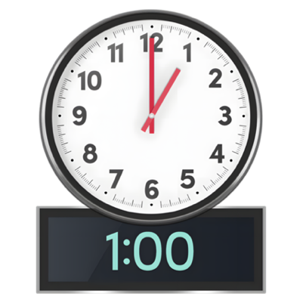



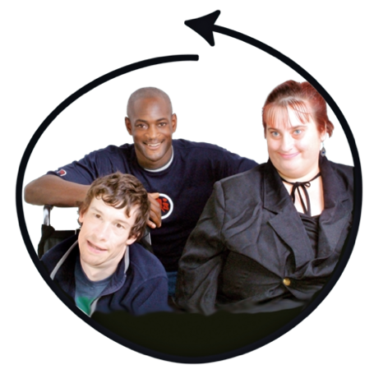

The time of the talk is

- 1.00 pm – 2.30 pm AEDT (NSW, VIC, ACT, TAS)
- 12.30 pm – 2.00pm (SA)

- 12.00 pm – 1.30 pm (QLD)
- 11.30 am – 1.00 pm (NT)
- 10.00 am – 11.30am (WA).

The talk is online on Zoom.

This talk is for
- People with disability
- Their families
- Support people
- Service providers
- People who care about people with disability.

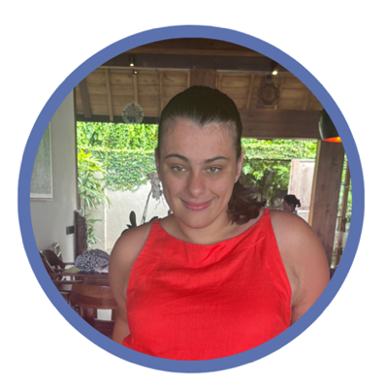

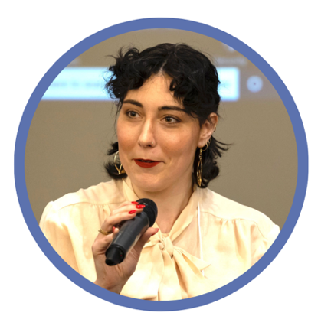

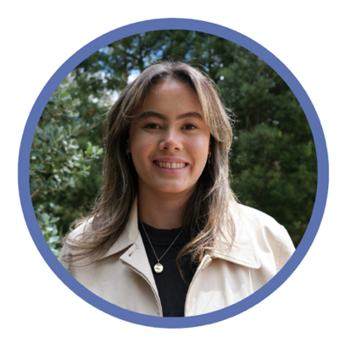

Sophie Geeves is co-hosting the event.
Sophie is a disability advocate and a Policy Consultant with Inclusion Australia.

Kiz Blanca-Jackson is co-hosting the event.
Kiz is a community organiser.

Madeleine Gay is a speaker at the event.
Madeleine is a disability advocate at Children and Young People with Disability Australia (CYDA).
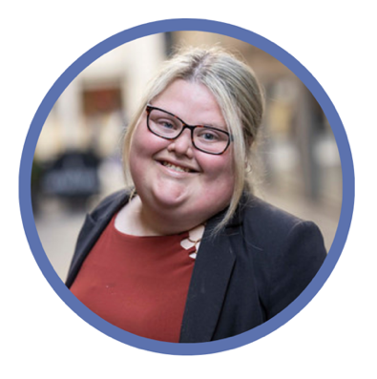
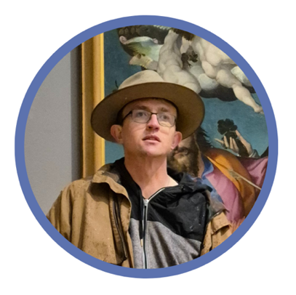

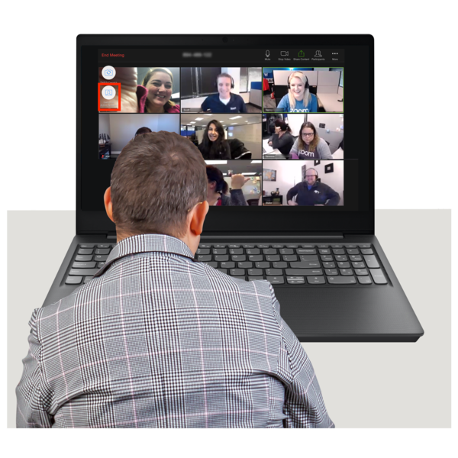
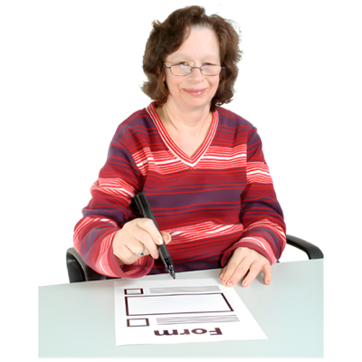
Brooke Canham is a speaker at the event.
Brooke is a policy officer at Inclusion Australia.

Ryan Rowland is a speaker at the event.
Ryan is a graduate of Up the Hill which is an organisation that helps people with an intellectual disability go to university.

If you would like to come to the talk please register at https://disabilitydialogue.com.au/events/save-the-date-for-the-february-open-dialogue/

After registering there is a survey which asks a few questions about what you think is important for students to do well in school.

The survey is in Easy Read.
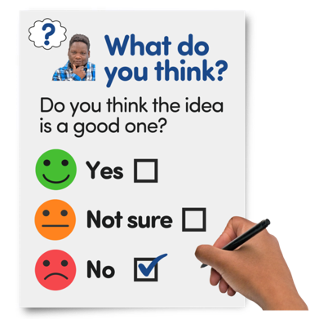





You do not have to fill out the survey if you do not want to.

We will send you the Zoom link for the talk in an email after you register.

We will send you the link again the day before the talk.

If you have any questions about the talk please email
info@disabilitydialogue.com.au

