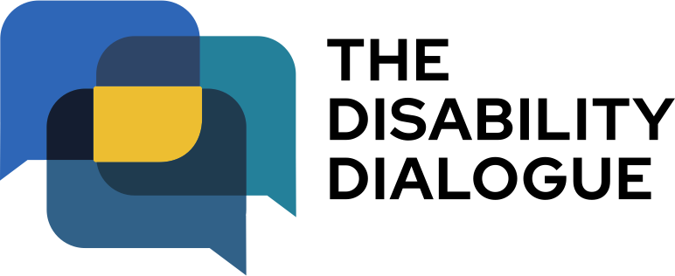

Open Dialogue event summary

Equal education for teens and young adults with disability

Contents

About the event…………………………………..3
What happened at the event…..………………..4

About the event

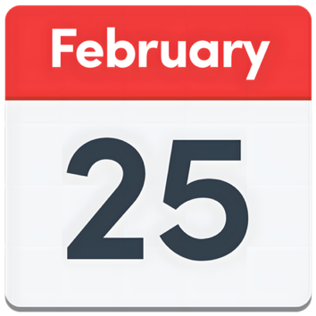

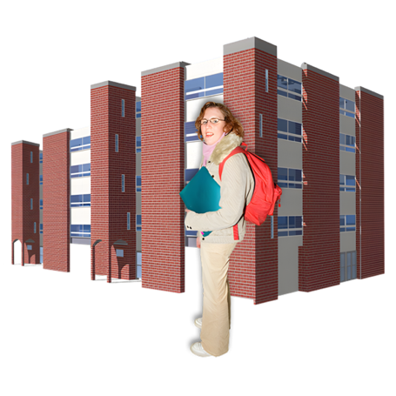

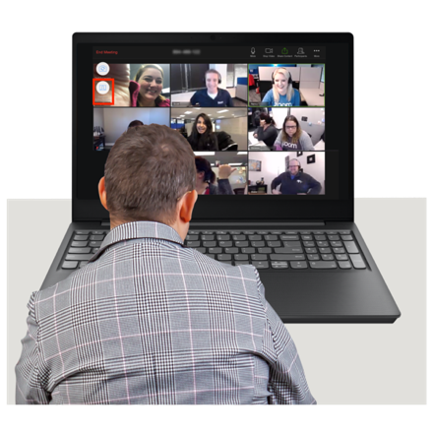

The Disability Dialogue had an event on Wednesday February 25 2026.

The event was about education for young people with disability who are in high school, university or TAFE.

You can watch the recording of the event here
https://www.youtube.com/watch?v=7OJEI-mzZcE&feature=youtu.be

What happened at the event

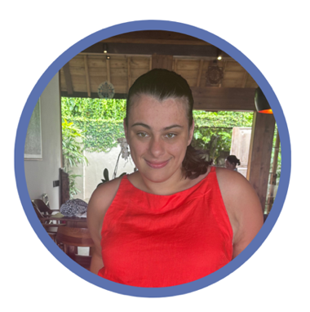
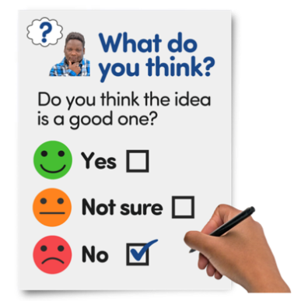
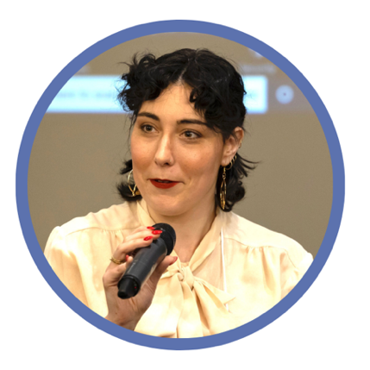

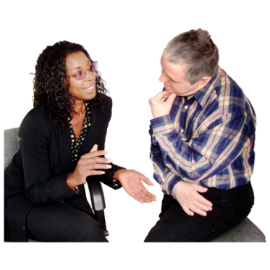
Sophie Geeves was a co-host at the event.
Sophie is a disability advocate.

Kiz Blanca-Jackson was also a co-host at the event.
Kiz is a disability advocate.

Kiz and Sophie started by sharing what they learned from the survey that some people filled out before the event.

Kiz and Sophie also talked about their own experiences in high school and university.

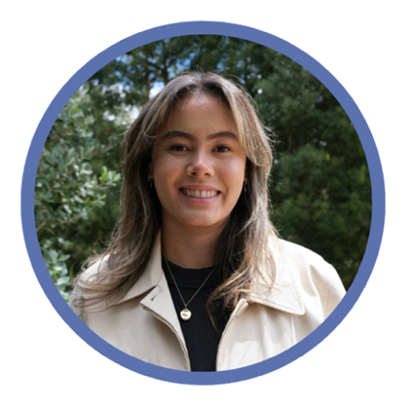
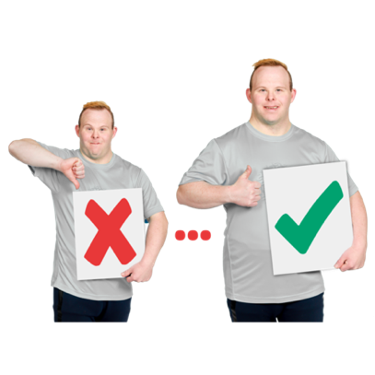
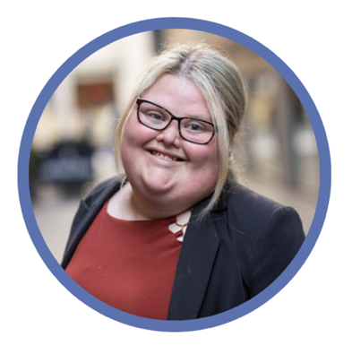

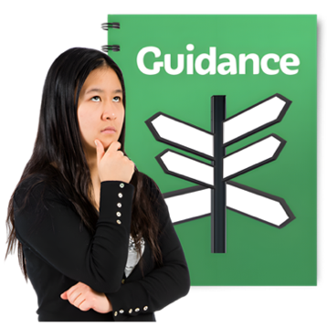
Madeleine Gay from Children and Young People with Disability was the first guest speaker.

Madeleine talked about how education can be better for young people with disability.

Brooke Canham from Inclusion Australia spoke next.

Brooke talked about the Polished Pathway.
The Polished Pathway shows how people with an intellectual disability are put on a different path from other people.
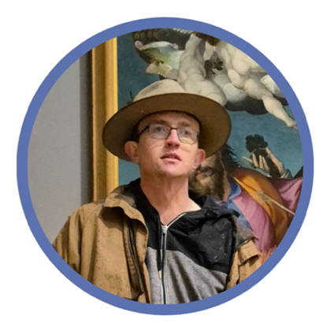
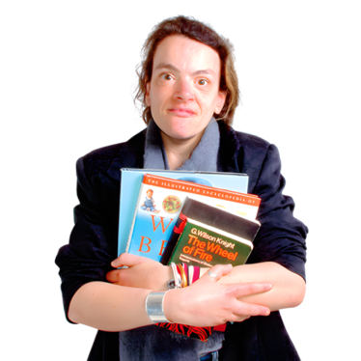

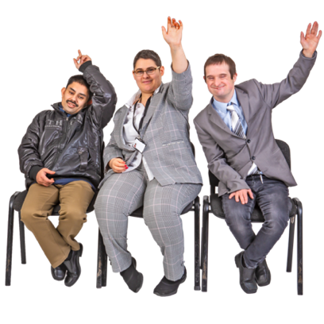
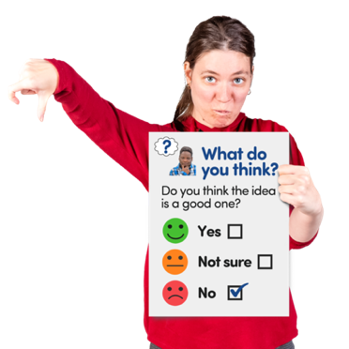

After a short break Ryan Rowland spoke.

He talked about his experience with Up the Hill which is an project that helps people with intellectual disability go to university.

The speakers answered some questions from the audience.

You can fill in an Easy read survey to tell us what you thought about the event.
https://www.rixeasysurvey.org/kiosk/JB04
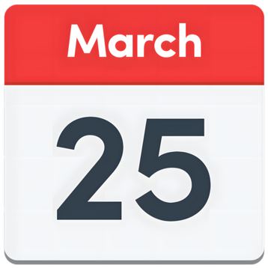

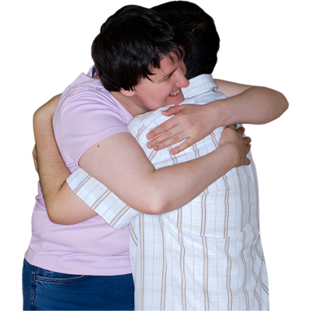

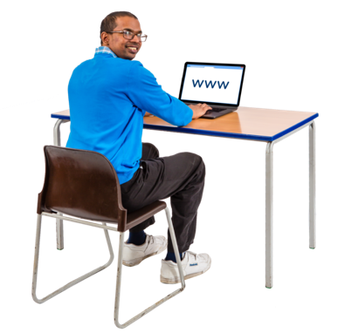

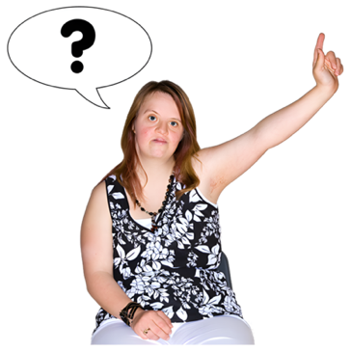

The next Disability Dialogue event will be on Wednesday 25 March.

The event will be about friendships and relationships for people with disability.

You can sign up to the next event at: https://disabilitydialogue.com.au/events/march-open-dialogue/

If you have any questions you can send them to info@disabilitydialogue.com.au

