Invitation from the Disability Dialogue:
Safe and happy relationships for people with disability

 | The Disability Dialogue wants you to come to a talk.
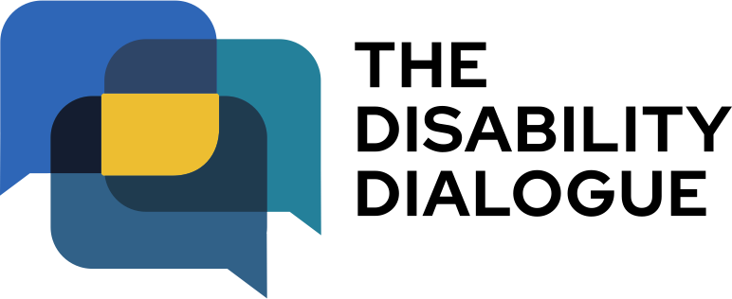 | The Disability Dialogue is a group of people who come together to talk about important things for people with disability.
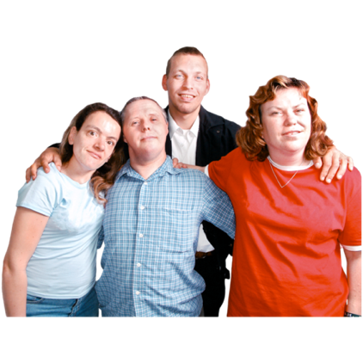 | The talk is about people with disability having safe and happy relationships.
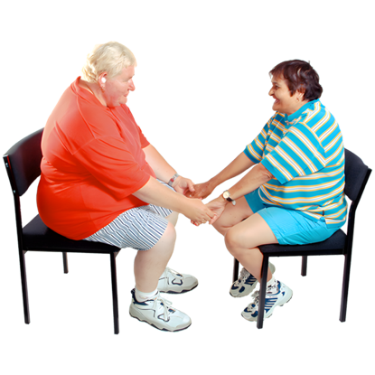 | Relationships are when we know and spend time with another person.  For example  - Family  - Friends  - Girlfriend or boyfriend  - Husband or wife
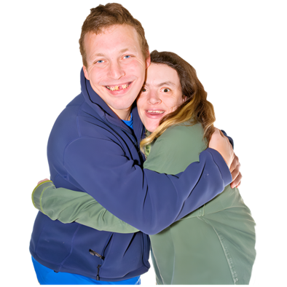 | At the event we will talk about what helps people with disability feel safe and happy with the people they have relationships with.
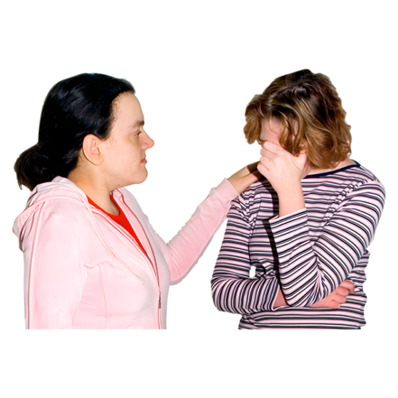 | We will also talk about things that make it hard for people with disability to have good relationships.
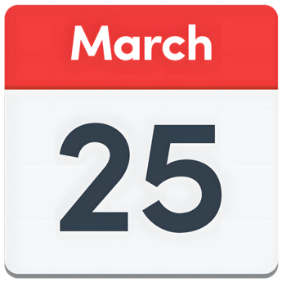 | The talk is on Wednesday 25 March 2026.
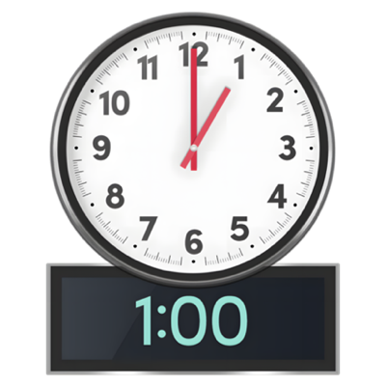 | The time of the talk is  - 1.00 pm – 2.30 pm (NSW, VIC, ACT, TAS)  - 12.30 pm – 2.00pm (SA)  - 12.00 pm – 1.30 pm (QLD)  - 11.30 am – 1.00 pm (NT)  - 10.00 am – 11.30am (WA).
 | The talk is online on Zoom.
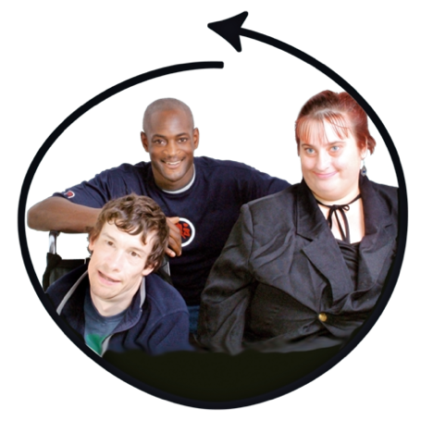 | This talk is for  - People with disability  - Their families  - Support people  - Service providers  - People who care about people with disability.
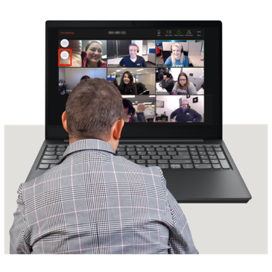 | If you would like to come to the talk please register at https://disabilitydialogue.com.au/events/march-open-dialogue/
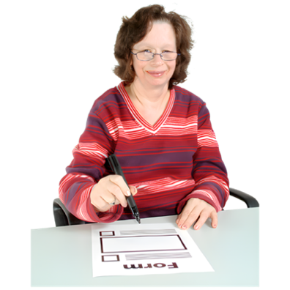 | After registering there is a survey which asks you a few questions about your experiences with relationships.  The survey is in Easy Read.
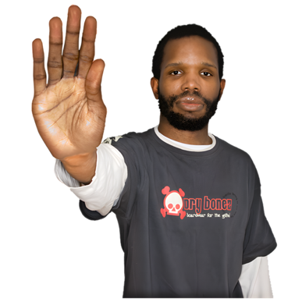 | You do not have to fill out the survey if you do not want to.
 | We will send you the Zoom link for the talk in an email after you register.
 | We will send you the link again the day before the talk.
 | If you have any questions about the talk please email info@disabilitydialogue.com.au

