Invitation from the Disability Dialogue:
Let’s talk about ableism

 | The Disability Dialogue wants you to come to a talk.
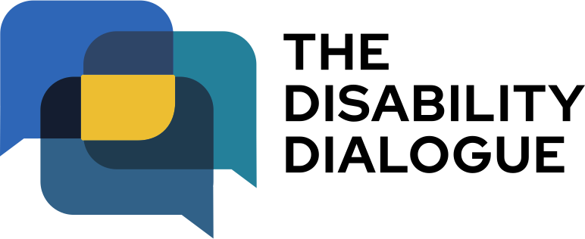 | The Disability Dialogue is a group of people who come together to talk about important things for people with disability.
 | The talk is about ableism.
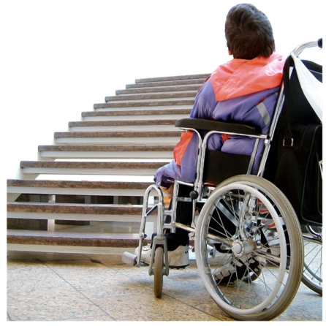 | Ableism is when people with disability are treated badly or unfairly because of their disability.
   | At the event we will hear people with disability talk about  - their experiences of ableism  - how ableism can make you feel  - how ableism can affect your everyday life.
 | We will also talk about disability pride.
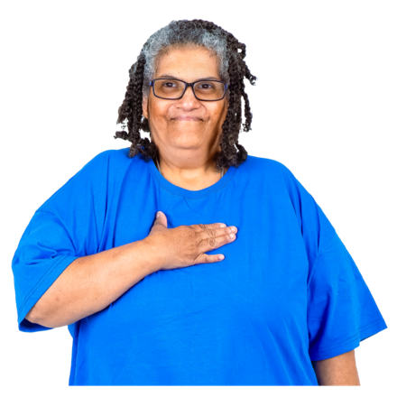  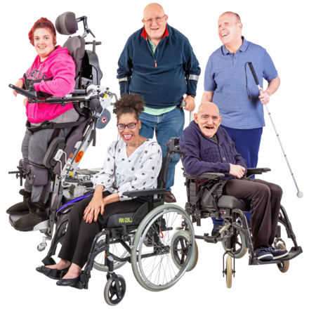 | Disability pride is when people with disability feel proud of who they are.  This means:  - seeing your disability as an important part of who you are  - being proud of who you are  - celebrating being a part of the disability community.
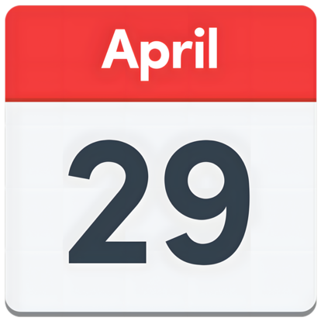 | The talk is on Wednesday 29 April 2026.
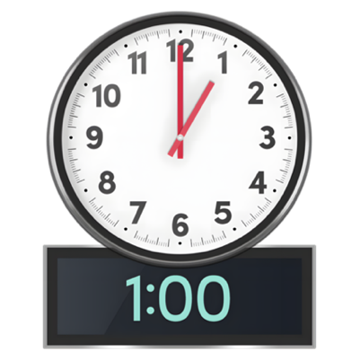 | The time of the talk is  - 1.00pm – 2.30pm (NSW, VIC, ACT, TAS, QLD)  - 12.30pm – 2.00pm (SA and NT)  - 11.00am – 12.30pm (WA)
 | The talk is online on Zoom.
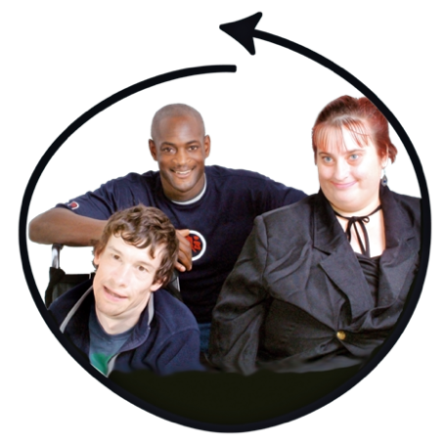 | This talk is for  - People with disability  - Their families  - Support people  - Service providers  - People who care about people with disability.
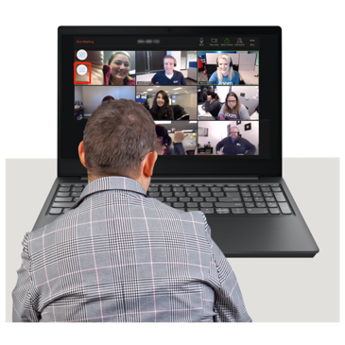 | If you would like to come to the talk please register at www.disabilitydialogue.com.au/events/april-open-dialogue/
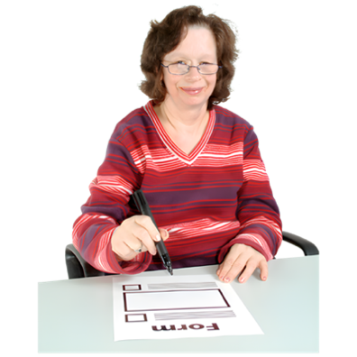 | After registering there is a survey which asks you to share your experiences of ableism.  The survey is in Easy Read.
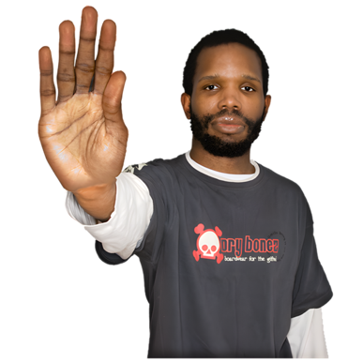 | You do not have to fill out the survey if you do not want to.
 | We will send you the Zoom link for the talk in an email after you register.
 | We will send you the link again the day before the talk.
 | If you have any questions about the talk please email info@disabilitydialogue.com.au

