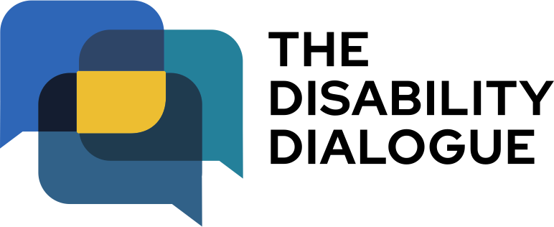

Open Dialogue event summary

Safe and happy relationships for people with disability

Contents

About the event…………………………………..3
What happened at the event…..………………..4

About the event

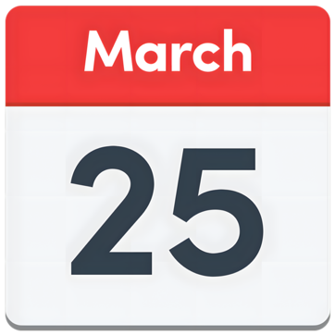 | The Disability Dialogue had an event on Wednesday March 25 2026.
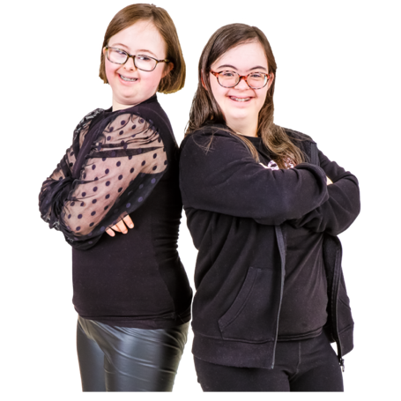 | The event was about safe and healthy relationships for people with disability.
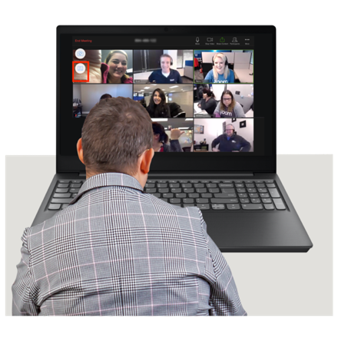 | You can watch the recording of the event here www.youtube.com/watch?v=yCsDx_pXqd8

What happened at the event

 | Jax Brown was a co-host at the event.  Jax is an LGBTQIA+ rights activist.
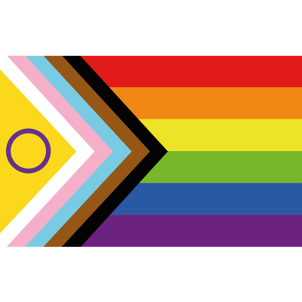 | LGBTQIA+ means  - Lesbian  - Gay  - Bisexual  - Transgender  - Queer  - Intersex  - Asexual  - or any other gender or sexuality you feel.
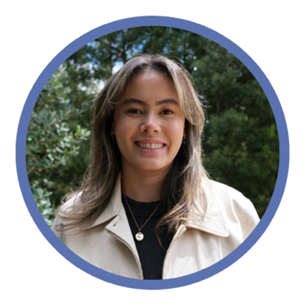 | Madeline Gay was a co-host at the event.  Madeline works at Children and Young People with Disability Australia (CYDA).
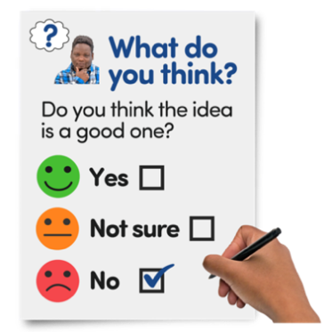 | Jax and Madeline shared what they learned from the survey that some people filled out before the event.
 | Daniel Johnston was the first guest speaker at the event.  Daniel has lots of friends and has a girlfriend.
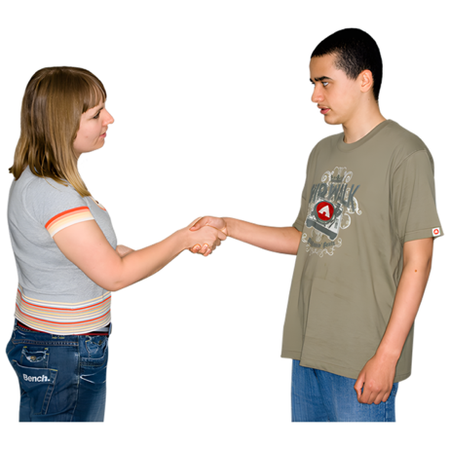 | Daniel talked about going out and meeting new people.  He also talked about how he met his girlfriend.
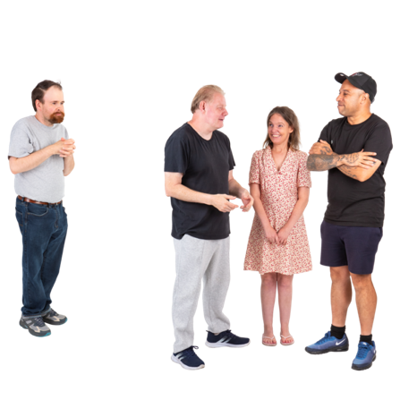 | Daniel gave advice about how to feel more confident when making new friends.
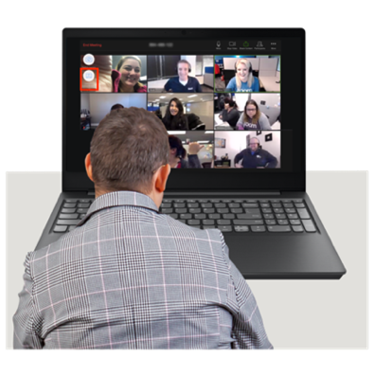 | We watched a video about how to support people with disability to have relationships.  You can watch the video here www.lwb.org.au/disability/relationships-intimacy-policy/
 | After a short break we watched a video about the right to choose how much you want to tell other people know about your relationships.  You can watch the video here www.youtube.com/watch?v=-hKIWnu4ZOI
 | Isabella Choate was the second speaker at the event.  Isabella is a disability advocate.
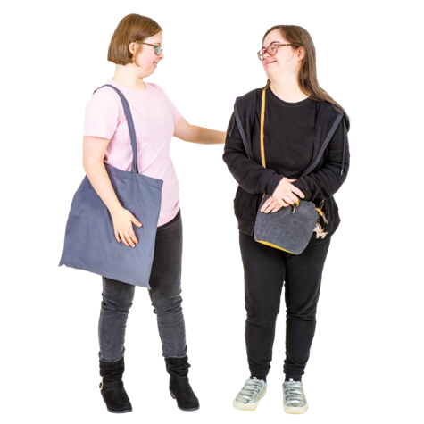 | Isabella talked about their experiences with relationships.  They talked about how relationships can look different for different people.
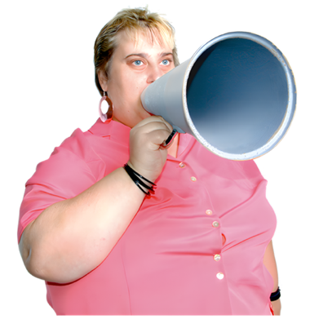 | Isabella talked about why it is important for people with disability to know their rights and to speak up for themselves in relationships.
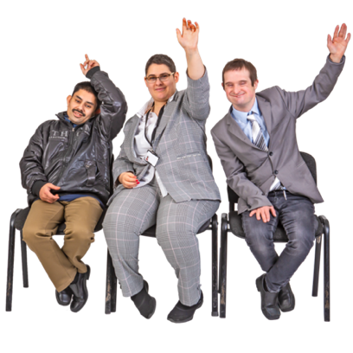 | Isabella and Daniel answered questions from the audience.
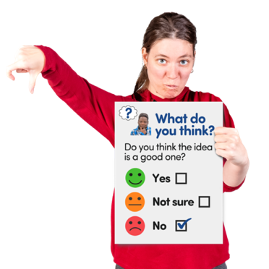 | You can fill in an Easy Read survey to tell us what you thought about the event if you want.  You can fill in the survey here www.rixeasysurvey.org/kiosk/PRRG
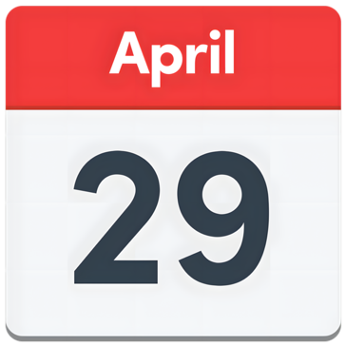 | The next Disability Dialogue event will be on Wednesday 29 April 2026.
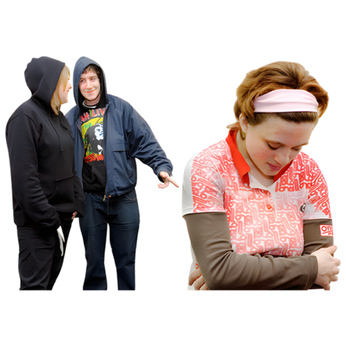 | The event is about how ableism affects people with disability.
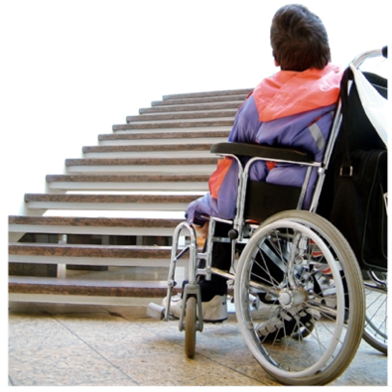 | Ableism is when people with disability are treated badly or unfairly because of their disability.
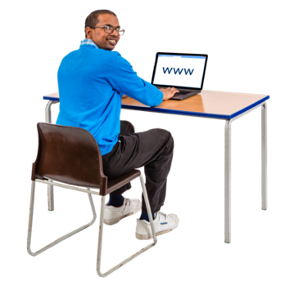 | You can register for the next event at www.disabilitydialogue.com.au/events/april-open-dialogue/
 | If you have any questions you can email us at info@disabilitydialogue.com.au

