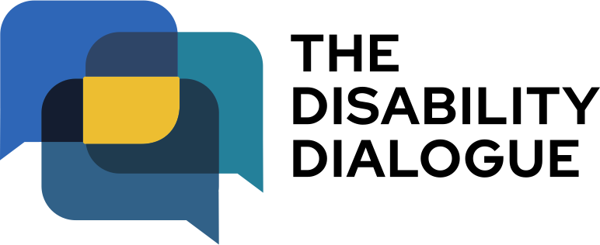

Open Dialogue event summary

Let’s talk about ableism

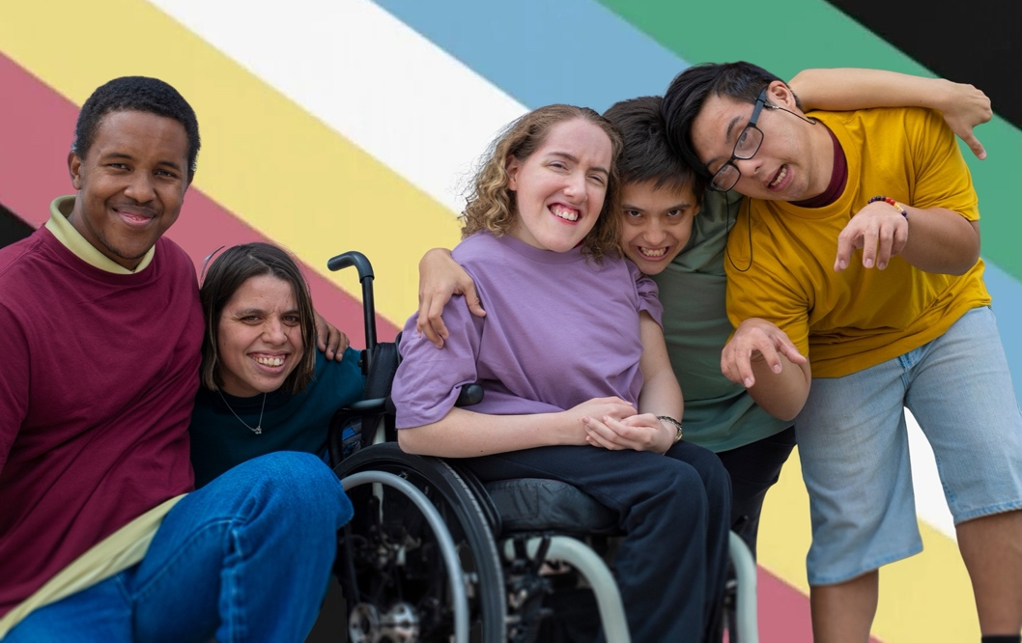

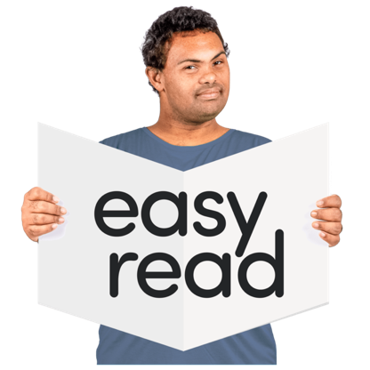
Contents

About the event…………………………………. 3
What happened at the event…..……………… 5
Our next event ………………………………… 11

About the event

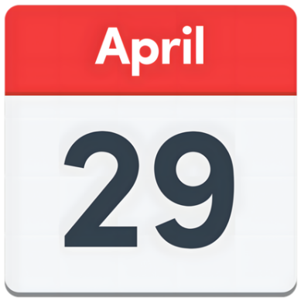 | The Disability Dialogue had an event on Wednesday 29 April 2026.
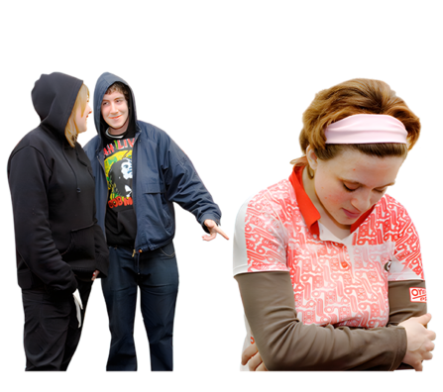 | The event was about ableism.
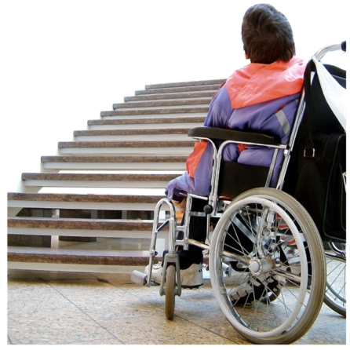 | Ableism is when people with disability are treated badly or unfairly because of their disability.
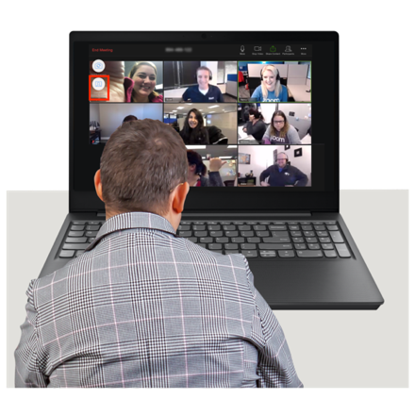 | You can watch the recording of the event here www.youtube.com/watch?v=93PmSjxt5zY

What happened at the event

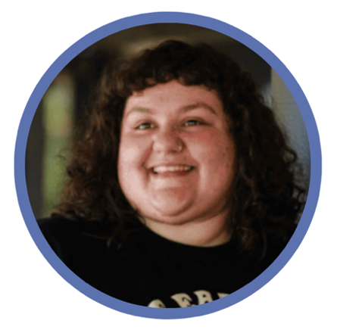 | Skye Cusack was a co-host at the event.  Skye is a writer and comedian with lived experience of disability.
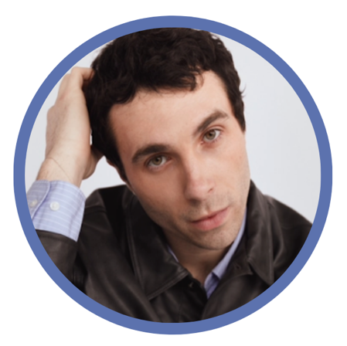 | James Parr was a co-host at the event.  James is a model and disability advocate with lived experience of disability.
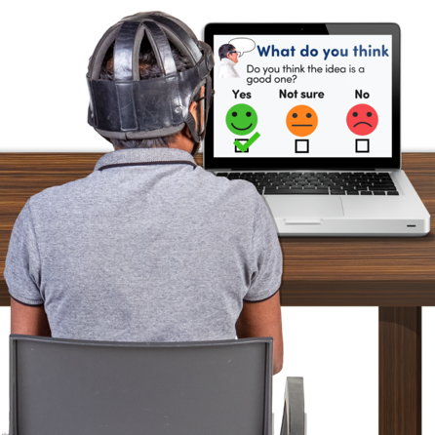 | Skye and James shared what they learned from the survey that some people filled out before the event.
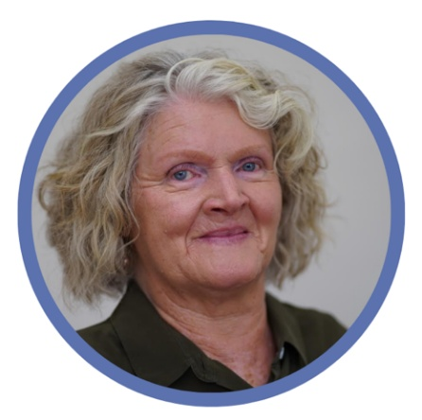 | Rosemary Kayess was a speaker at the event.  Rosemary is the Disability Discrimination Commissioner.  Her job is to help protect the rights of people with disability.
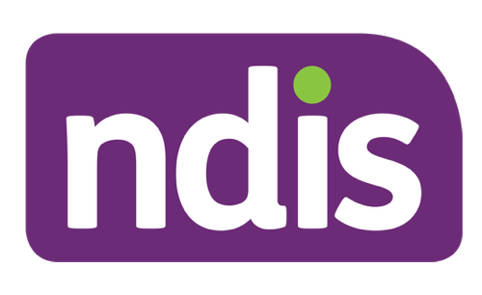 | Rosemary talked about changes to the National Disability Insurance Scheme (NDIS).
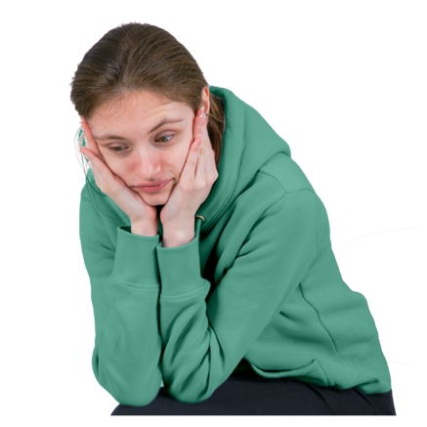 | Rosemary said people with disability are worried about the changes.
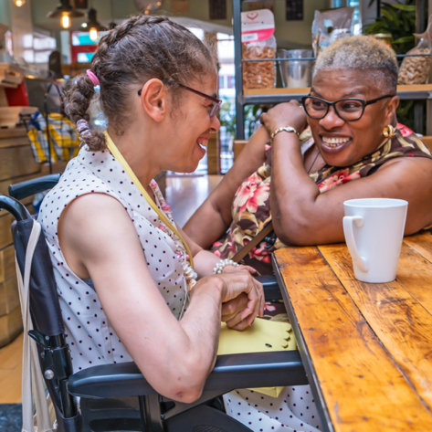 | Rosemary said the NDIS needs to focus more on supporting people to be part of their communities.
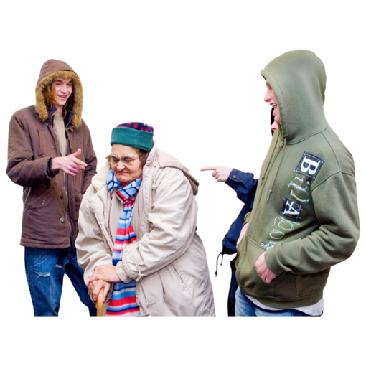  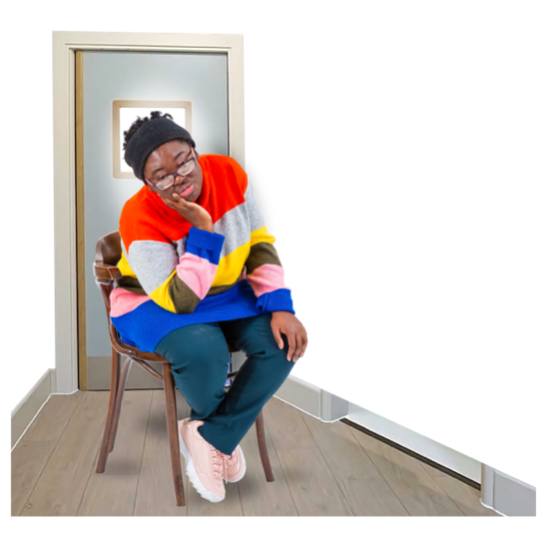 | Rosemary also talked about how ableism hurts people.  Rosemary said people with disability are hurt when  - They are separated the rest of the community  - Their disability is seen as something that is wrong or bad.
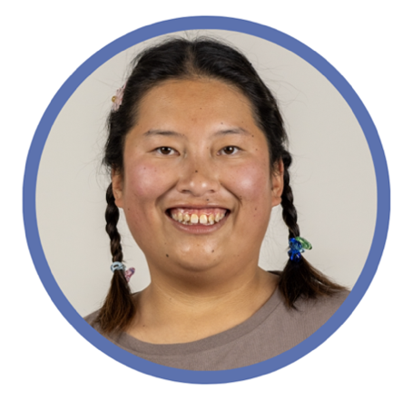 | Laura Naing spoke at the event.  Laura has an intellectual disability and works at the NSW Council for Intellectual Disability (CID).
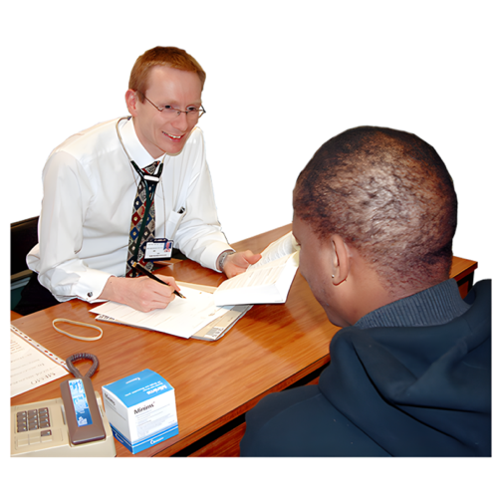 | Laura talked about how doctors have treated her unfairly because of her intellectual disability.
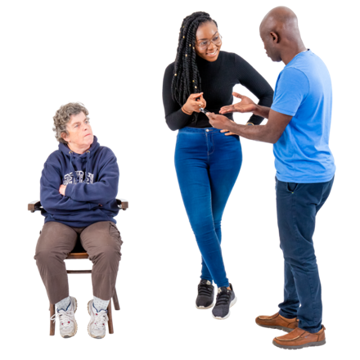 | Laura said doctors judged her without asking her questions.
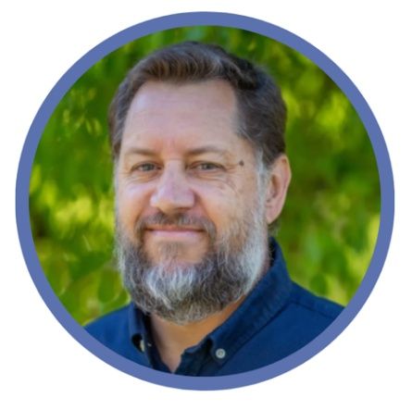 | Barnaby Lund spoke at the event.  Barnaby is deaf and helps organisations be more inclusive.
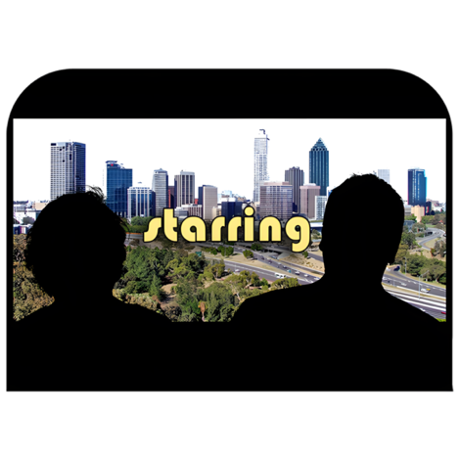 | Barnaby talked about how he started a club called Deaf Movie Club Brisbane.
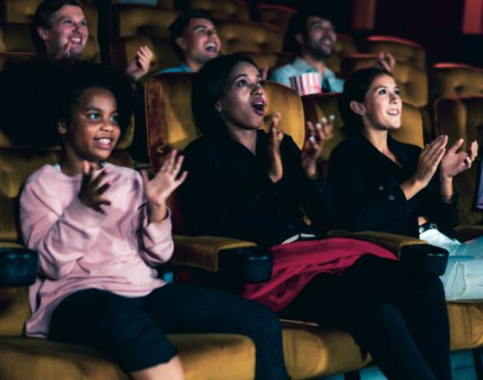 | He said cinemas should have captions on screen to make movies more accessible.
 | Captions are words on the screen to show what is being said and heard.
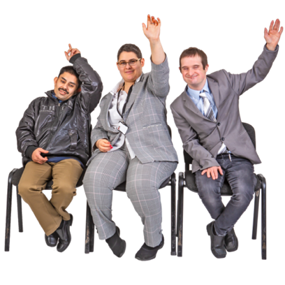 | All the speakers answered questions from the audience at the end.
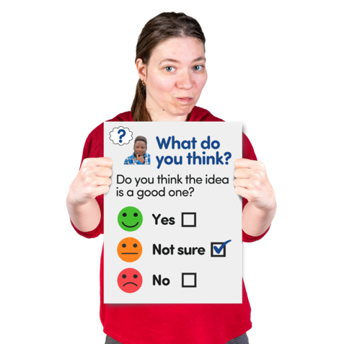 | You can fill in an Easy Read survey to tell us what you thought about the event if you want.  You can fill in the survey at www.rixeasysurvey.org/kiosk/JBYq

Our next event

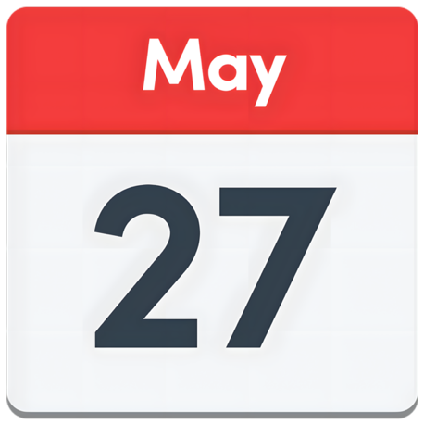 | The next Disability Dialogue event will be on Wednesday 27 May 2026.
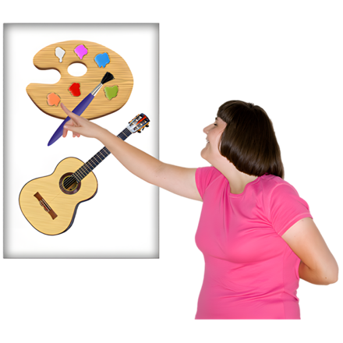 | The event will be about disability arts.
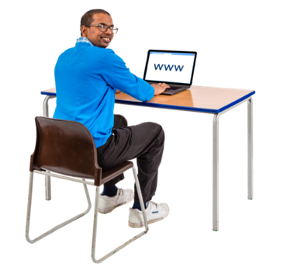 | You can register for the next event at www.disabilitydialogue.com.au/events/may-open-dialogue/
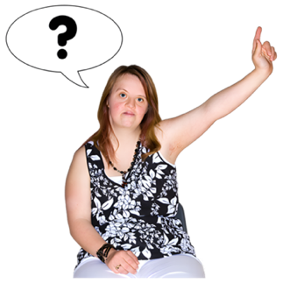 | If you have any questions you can email us at info@disabilitydialogue.com.au

