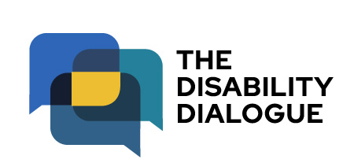

Invitation from the Disability Dialogue: Art and stories from people with disability

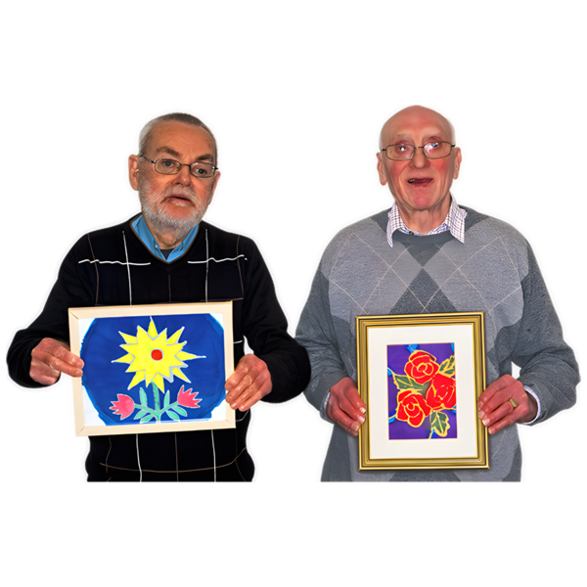

 | The Disability Dialogue wants you to come to a talk.
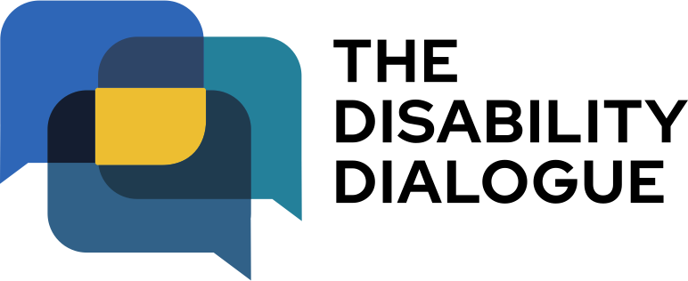 | The Disability Dialogue is a group of people who come together to talk about important things for people with disability.
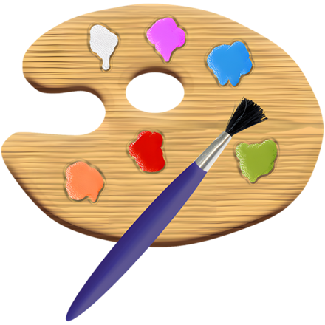 | This talk is about art and telling stories.
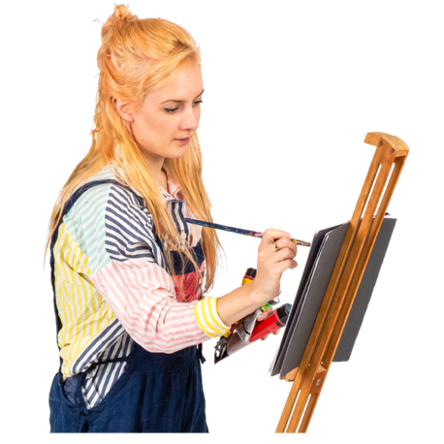 | People with disability use art to:  - Tell stories  - Show who they are  - Connect with other people.
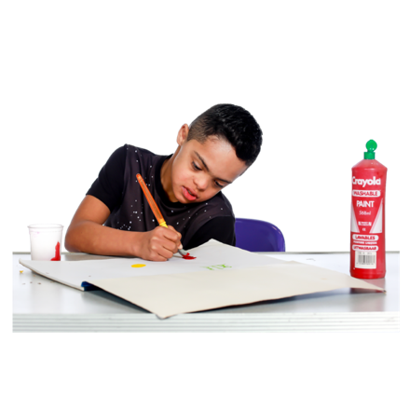 | We will talk about what helps people with disability make art.
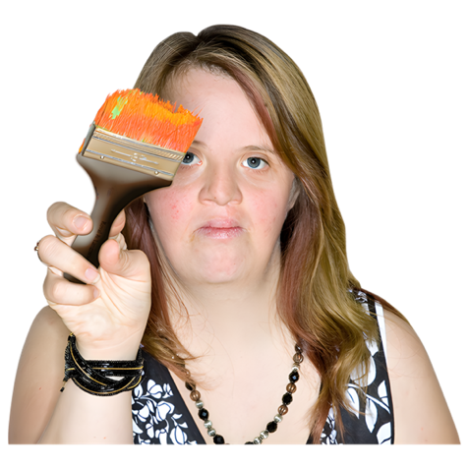 | We will also talk about how people with disability use art to:  - Speak up for themselves  - Celebrate the disability community.
 | The talk is on Wednesday 27 May 2026.
 | The time of the talk is  - 1:00pm-2:30pm (NSW, VIC, ACT, TAS, QLD)  - 12:30pm-2:00pm (SA, NT)  - 11:00am-12:30pm (WA).
 | The talk is online on Zoom.
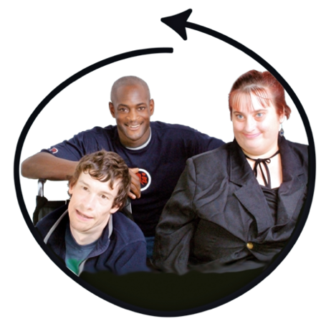 | This talk is for:  - People with disability  - Their families  - Support people  - Service providers  - People who care about people with disability.
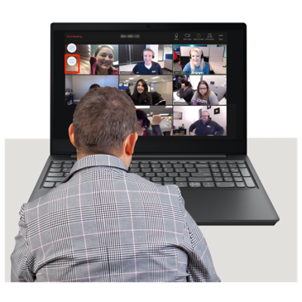 | If you would like to come to the talk please register at https://disabilitydialogue.com.au/events/may-open-dialogue/
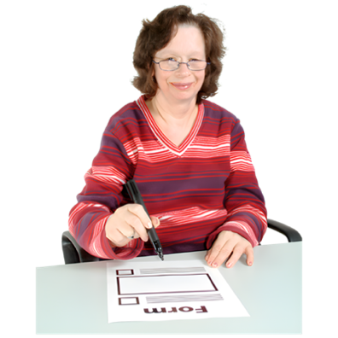 | After registering there is a survey which asks you a few questions about your experiences with art and creativity.  The survey is in Easy Read.
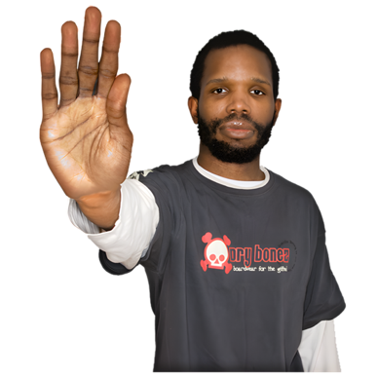 | You do not have to fill out the survey if you do not want to.
 | We will send you the Zoom link for the talk in an email after you register.
 | We will send you the link again the day before the talk.
 | If you have any questions about the talk please email info@disabilitydialogue.com.au

