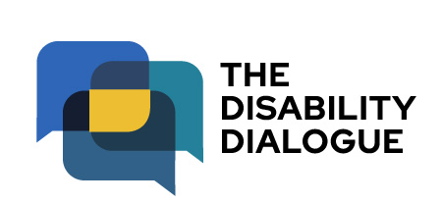

Open Dialogue event summary
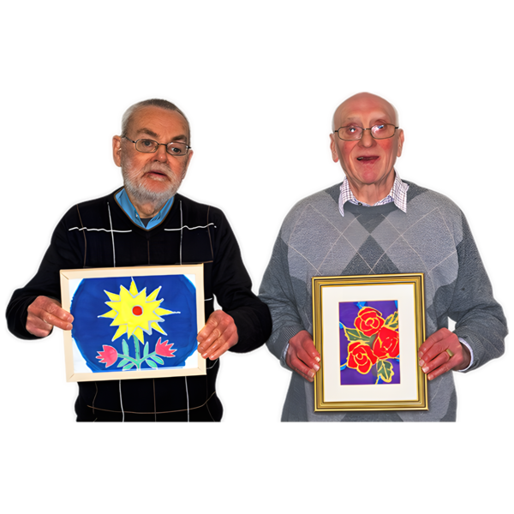
Art and stories from people with disability

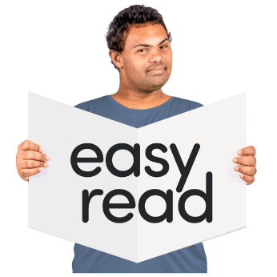
Contents
About the event 3
What happened at the event 4
Our next event 9

About the event

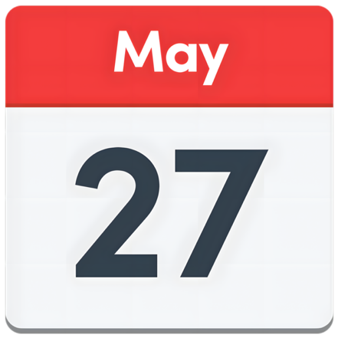 | The Disability Dialogue had an event on Wednesday 27 May 2026.
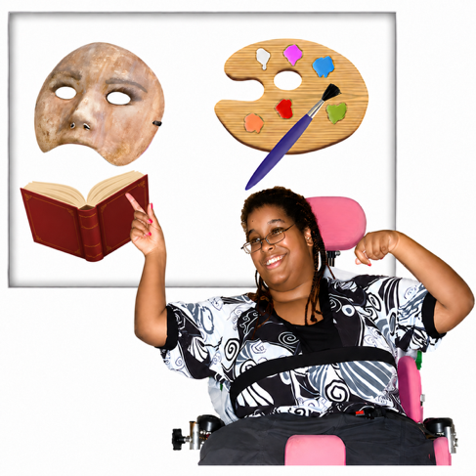 | The event was about art and telling stories.
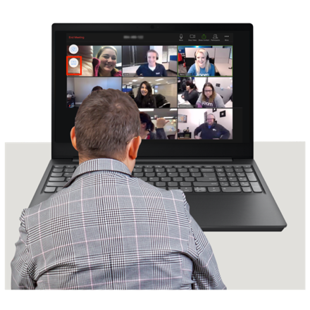 | You can watch the recording of the event here https://www.youtube.com/watch?v=oEDrLMmmhmc

What happened at the event
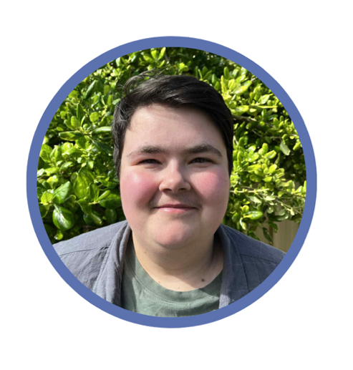 | G Treloar was a co-host at the event
 | G is a person with disability who is a stage manager.  A stage manager is someone who helps organise live shows and events.
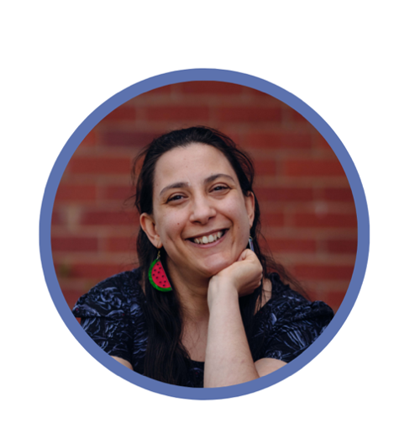 | Laura Pettenuzzo was a co-host at the event.  Laura is a person with disability who is a writer and disability advocate.
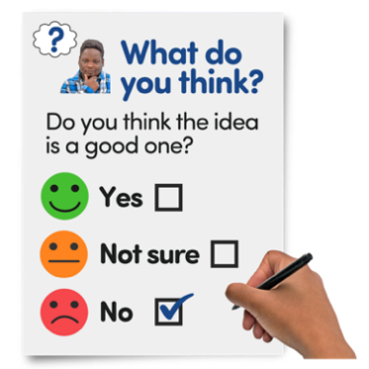 | G and Laura shared what they learned from the survey that some people filled out before the event.
 | Dylan McBurney was a speaker at the event.  Dylan is a person with disability who is a stage manager and actor.
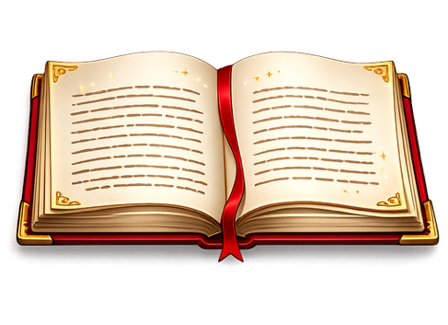   | Dylan talked about how comedy can help people with disability tell their own stories.  Dylan said people with disability can find it harder to take part in art if they do not have the support they need.
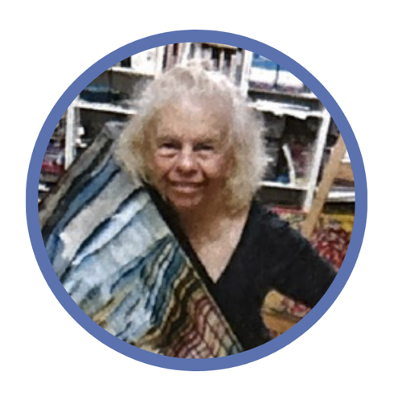 | Deb Costin spoke at the event.  Deb is a person with an intellectual disability who is an artist.
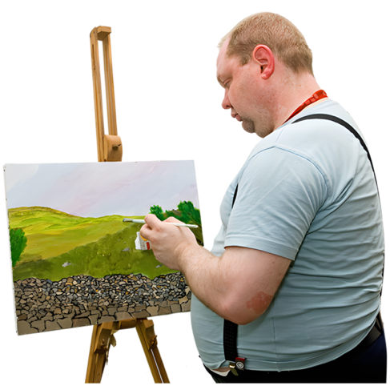 | Deb showed everyone some of her artworks.  She talked about the meaning of each artwork.
 | Deb talked about how anyone can make art.
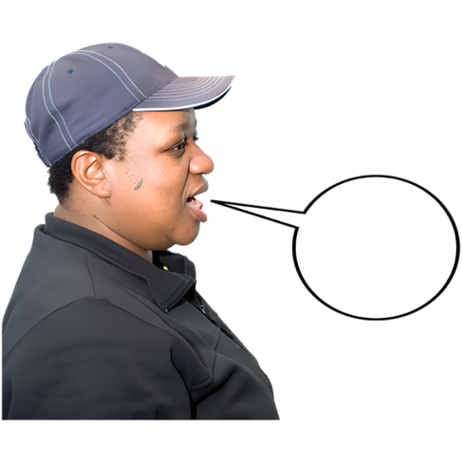 | G and Laura told their own stories about making or being involved with art.
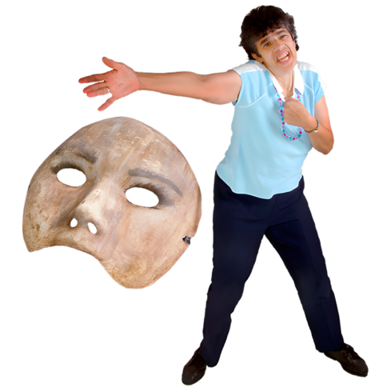 | G talked about helping put on plays.  They said theatre can sometimes be hard for people with disability to take part in.
 | Laura talked about how she uses writing to share her experiences as a person with disability.
 | Laura said she wants her writing to help other people with disability to speak up for themselves.
 | All the speakers answered questions from the audience at the end of the event.
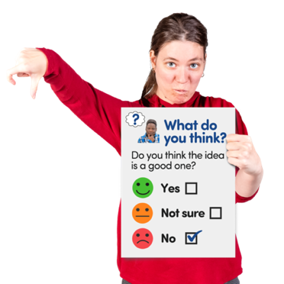 | You can fill in an Easy Read survey to tell us what you thought about the event if you want.  You can take the survey here https://www.rixeasysurvey.org/kiosk/Pvxl

Our next event

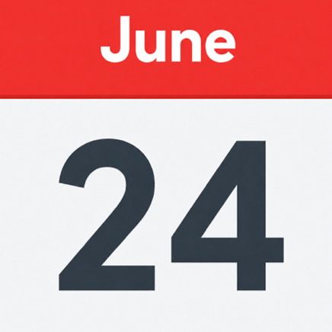 | The next Disability Dialogue event will be on Wednesday 24 June 2026.
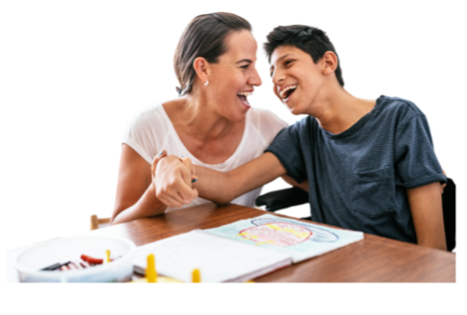 | The event will be about changes to the National Disability Insurance Scheme.
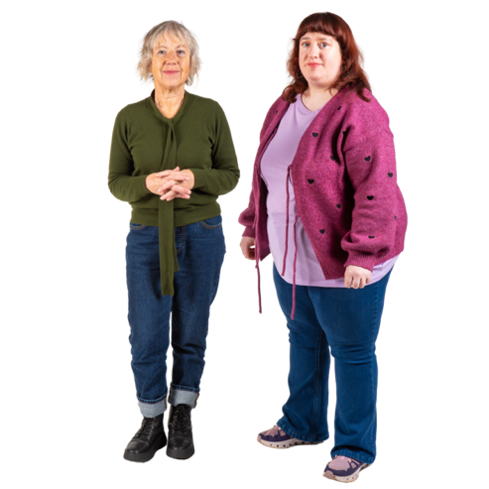 | The National Disability Insurance Scheme gives some people with disability help to get the supports and services they need.  We say NDIS for short.
 | You can register for the next event at https://disabilitydialogue.com.au/events/june-open-dialogue/
 | If you have any questions you can email us at info@disabilitydialogue.com.au

