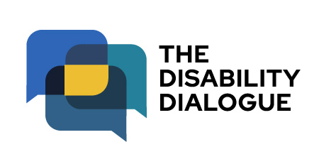

Invitation from the Disability Dialogue: Talking about changes to the NDIS
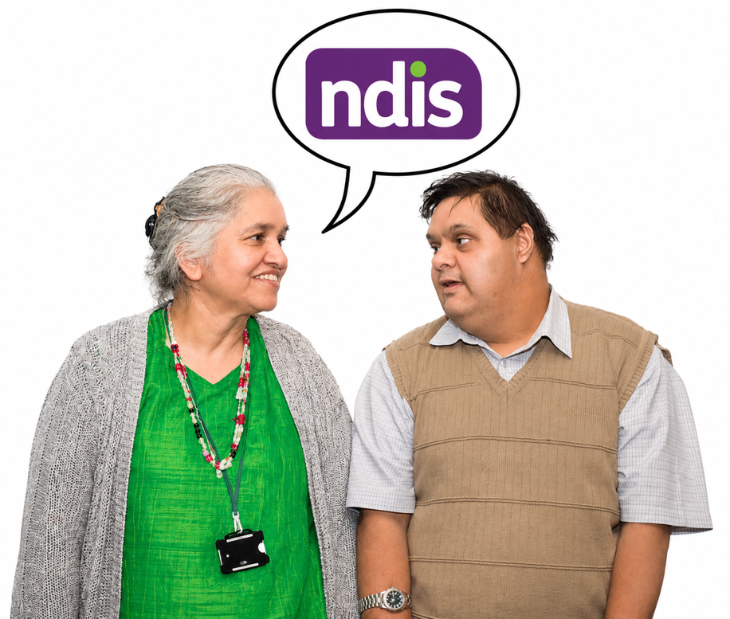


 | The Disability Dialogue wants you to come to a talk.
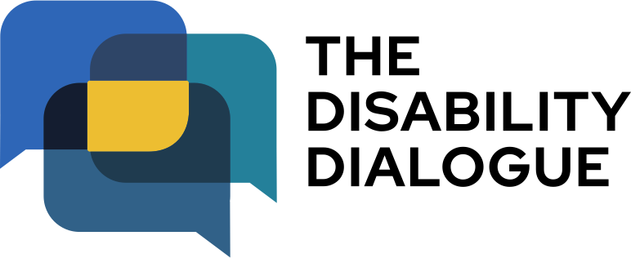 | The Disability Dialogue is a group of people who come together to talk about important things for people with disability.
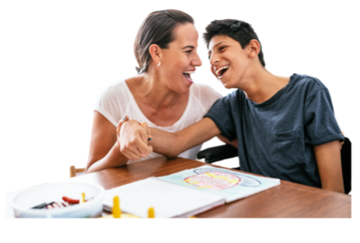 | The talk is about changes to the National Disability Insurance Scheme.
 | The National Disability Insurance Scheme gives some people with disability help to get the supports and services they need.  We say NDIS for short.
 | In April 2026 the Australian Government announced some changes they want to make to the NDIS.
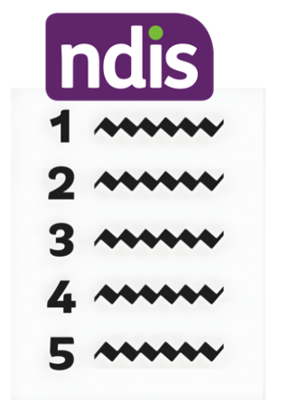 | Some of these changes include:  - Changes to who can get support from the NDIS  - Changes to the types of support people can get  - Changes to how the NDIS works.
 | These changes are making many people with disability feel:  - Angry  - Scared  - Confused.
 | The Disability Dialogue wants to create a safe space to talk about changes that may happen to the NDIS.
 | At the talk we will:  - Hear from people with disability who know a lot about the NDIS  - Talk about what the changes could mean for people with disability  - Answer your questions as best as we can.
 | The talk is on Wednesday 24 June 2026.
 | The time of the talk is:  - 1.00pm – 2.30pm (NSW, VIC, ACT, TAS, QLD)  - 12.30pm – 2.00pm (SA, NT)  - 11.00am – 12.30pm (WA)
 | The talk is online on Zoom.
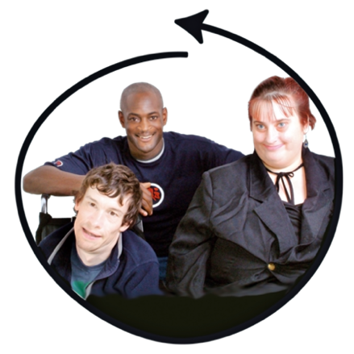 | The talk is for  - People with disability  - Their families  - Support people  - Service providers  - People who care about people with disability.
 | You can bring a support person with you if you like.
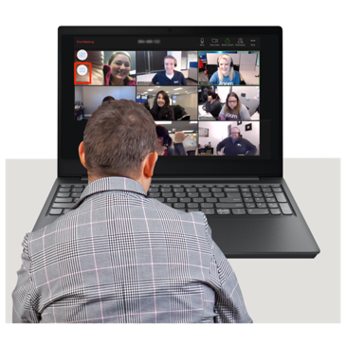 | If you would like to come to the talk please register at www.disabilitydialogue.com.au/events/june-open-dialogue/
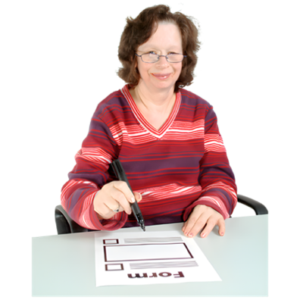 | After registering there is a survey which asks you a few questions about the changes the Government wants to make to the NDIS.  The survey is in Easy Read.
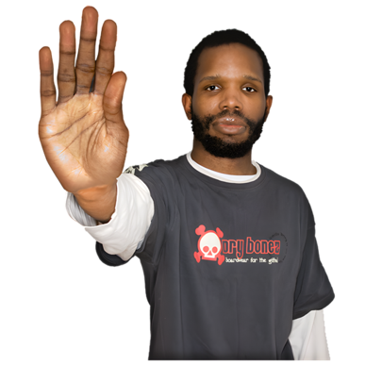 | You do not have to fill out the survey if you do not want to.
 | We will send you the Zoom link for the talk in an email after your register.
 | We will send you the link again the day before the talk.
 | If you have any questions about the talk please email info@disabilitydialogue.com.au

